Parent Guide – Changing Me - What will my child be learning in these lessons?
Age 4-5 | Detail
My body | Naming body parts (no genitalia).
Respecting my body | Healthy food choices.
Growing up | We all grow from babies to adults.
Fun and Fears Part 1 | Moving to a new class.
Fun and Fears Part 2 | Continuation of above – moving to Year 1.
Celebration | Memory box – favourite things from the year.

Age 5-6 | Detail
Life cycles | The life cycle of animals and humans (frogs/humans).
Changing me | What I can do now compared to when I was a baby.
My changing body | Continued from above – how have our bodies changed and our abilities. Body changes – taller, stronger, can read and write.
Boys’ and girls’ bodies | Not taught
Learning and growing | Understanding when we learn something, we change.
Coping with changes | Talking about change and how to cope with it.

Age 6-7 | Detail
Life cycles in nature | Cycles of life in nature. Some changes are outside my control. Understanding how I feel about this.
Growing from young to old | Understanding that this is a normal process and outside of our control.  Identify older people who I respect.
The changing me | Recognise how my body has changed since I was a baby and where I am on the continuum from young to old.  Feel proud about becoming more independent.
Boys’ and girls’ bodies | Not taught
Assertiveness | Understand there are different types of touch. Can say the ones I like and don’t like. I am confident to say what I like and don’t like and can ask for help. (Link to: NSPCC PANTS message/Speak out, Stay safe)
Looking ahead | Identify what I am looking forward to when I move to my next class.  Think about changes I will make when I am in my next class and know how to go about this.

Age 7–8 | Detail
How babies grow | Not taught
Babies | Not taught
Outside body changes | This lesson will be amended and will continue from previous lessons about growing up and changing. These will focus on changes not including genitalia. For example: taller in height, skin changes, know more etc.
Inside body changes | Not taught
Family Stereotypes | Recognise stereotypical ideas I might have about parenting and family roles.  Express how I feel when my ideas are challenged and might be willing to change my ideas sometimes.
Looking ahead | Identify what I am looking forward to when I move to my next class.  Think about changes I will make next year and know how to go about this.

Age 8–9 | Detail
Unique me | Understand that some of my personal characteristics have come from my parents (and that this happens because I am made from the joining of their egg and sperm – removed)  Appreciate that I am a truly unique human being.
Having a baby | Not taught
Having a baby (Alternative) | Not taught
Girls and puberty | Not taught
Circles of change | Know how the circle of change works and can apply it to changes I want to make in my life. Confident enough to try to make changes when I think they will benefit me.
Accepting change | Identify changes that have been and may continue to be outside of my control that I learnt to accept.  Express my fears and concerns about changes that are outside of my control and know how to manage these feelings positively.
Looking ahead | Identify what I am looking forward to when I move to my next class.  Think about changes I will make next year and know how to go about this.

Age 9-10 | Detail
Self-image and body image | Aware of my own self-image and how my body image fits into that.  Know how to develop my own self esteem.
Puberty for girls | Explain how a girl’s body changes during puberty and understand the importance of looking after myself physically and emotionally.  Understand that puberty is a natural process that happens to everybody and that it will be OK for me.  DO NOT TEACH REPRODUCTION., However uterus/womb, ovaries and vagina will be taught here to explain how menstruation occurs.
  Teach in separate sex classes
Puberty for boys | Describe how boys’ and girls’ bodies change during puberty.  Express how I feel about the changes that will happen to me during puberty.  DO NOT TEACH REPRODUCTION.
  Teach in separate sex classes
Conception | Not taught
Looking ahead 1 | Identify what I am looking forward to about becoming a teenager and understand this brings growing responsibilities.  Confident that I can cope with the changes that growing up will bring.
Looking ahead 2 | Identify what I am looking forward to when I move to my next class.  Think about changes I will make next year and know how to go about this.

Age 10-11 | Detail
My self-image | Aware of my own self-image and how my body image fits into that.  Develop my own self esteem.
Year 6 –Puberty | Lesson developed around these videos. QR codes available in school reception.  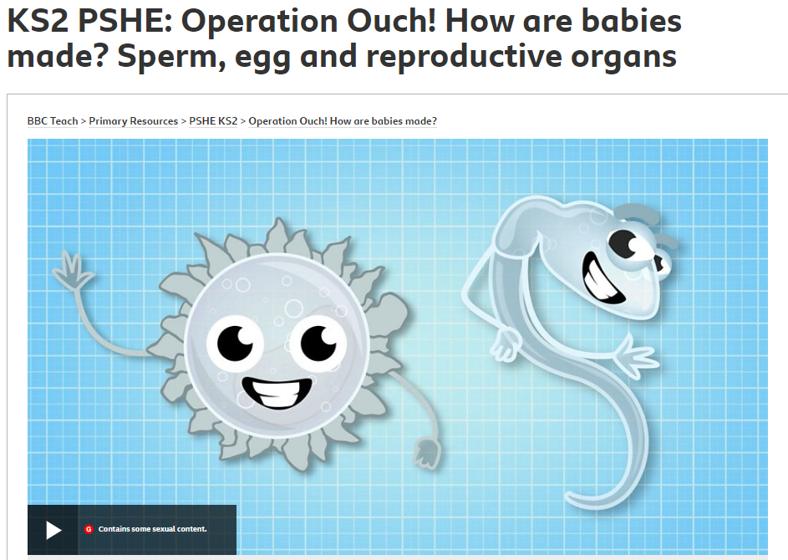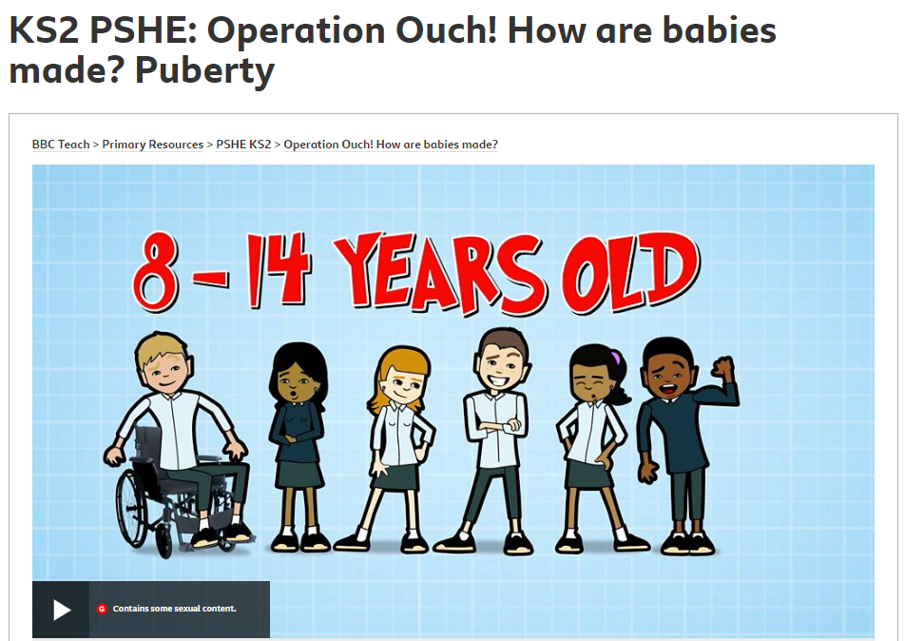
  Teach in separate sex classes
Year 6 - Babies – conception to birth | Lesson developed around these videos. QR codes available in school reception.  RIGHT TO WITHDRAW  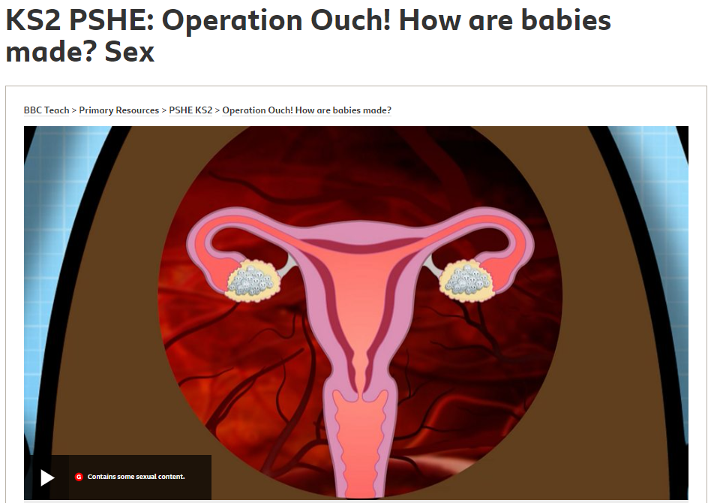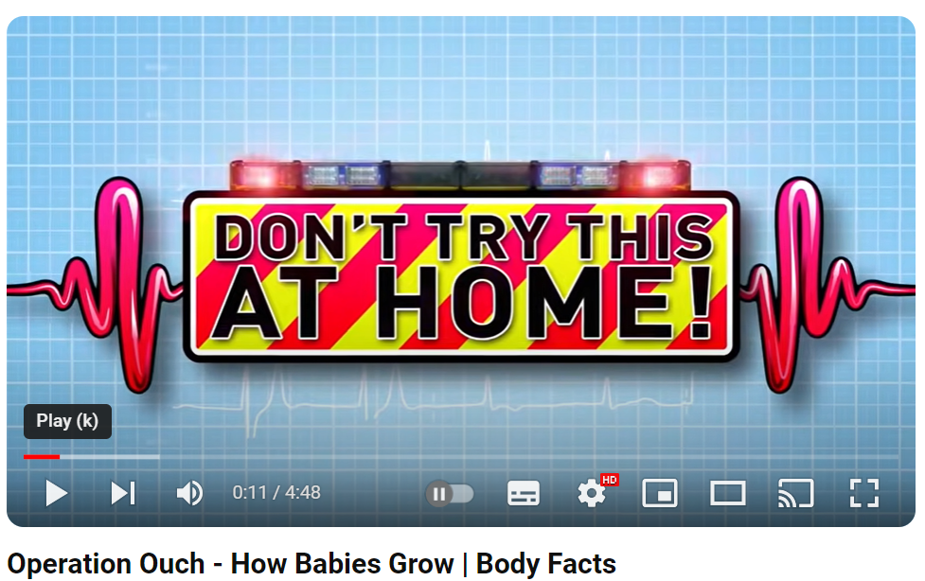
  Teach in separate sex classes
Boyfriends and girlfriends | Understand how being physically attracted to someone changes the nature of the relationship and what that might mean about having a girlfriend or  boyfriend. Understand that respect for one another is essential in a boyfriend/girlfriend relationship, and that I should not feel pressured into doing something I don’t want to.
Adolescent friendships – Alternative | Know myself well enough to maintain positive relationships with others whilst still keeping my own identity. Be assertive when appropriate.
Real self and ideal self | Aware of the importance of a positive self-esteem and what I can do to develop it.  Express how I feel about my self-image and know how to challenge negative ‘body-talk’.
The year ahead | Identify what I am looking forward to and what worries me about the transition to secondary school or moving to my next class.  Know how to prepare myself emotionally for the changes next year.

