We are proud to inform you that Arboretum Primary school is an Inclusive Attendance school.
At our school, we are driven by a commitment to making school attendance a top priority, fully integrated with every aspect of school improvement. Using the Inclusive Attendance Model – the first and only accredited programme providing the pedagogy of practice – we support children and families to connect, belong, and thrive.

Inclusive Attendance Professional Development Model
The Inclusive Attendance professional development model fundamentally guides our attendance approach. Comprising six tailored Learning Modules, this model empowers us to deepen our understanding by facilitating continuous professional learning for all staff. Within this model, the four domains of practice ensure the provision of professional learning, professional development, evidence-based practices, and exemplary leadership and management seamlessly integrate theory into practice.

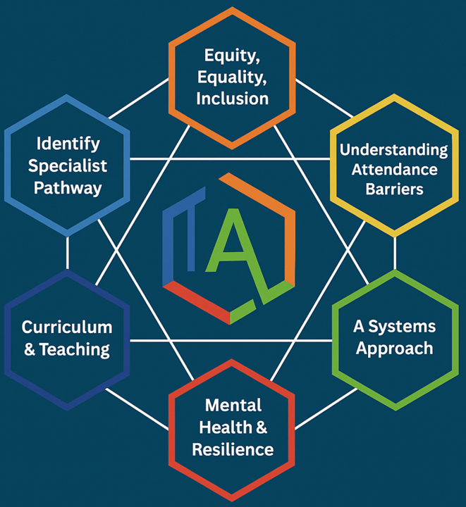

Inclusive Attendance Implementation Programme
Each year, Arboretum Primary school reviews and further enhances attendance practices through dedicated participation in the Inclusive Attendance 7-month implementation programme. This investment allows us to remain at the forefront of educational change and extends unparalleled support to our children and their families, equipping them with access to the best possible support.

Impact and Collaboration
Through our ongoing yearlong implementation programme, and five-year long-term strategy, we deliver measurable impact by creating an inclusive attendance culture and improving outcomes for all children and young people. We are outward facing in our approach and value working regionally and nationally, through a systems-led model with other schools and external agencies. We continually strengthen and enhance our offer year on year. This work is underpinned by ongoing accredited CPD for staff each year, ensuring sustainable change, stronger outcomes for children and young people, and a deeply embedded culture of collective responsibility.

Multi-Tiered System of Support
To guarantee a comprehensive approach to attendance, we implement a Multi-Tiered System of Support. A Multi-Tiered System of Support (MTSS) for school attendance involves three tiers of intervention, with roles for teachers, the school, children, parents, and external agencies – including the Local Authority. Data-driven decision-making and training requirements are pivotal to the implementation of the system. The system aligns with the Department for Education's (DFE) "Working Together to Improve School Attendance" guidelines.
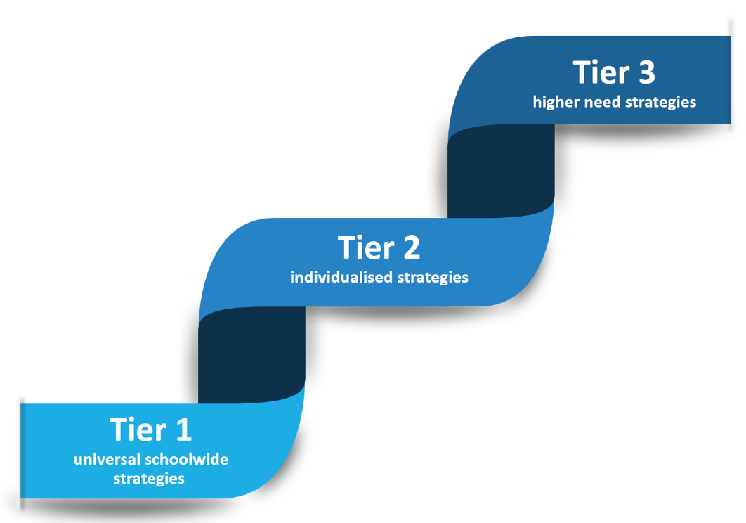

Tier 1 - Universal Approach: Establishing a baseline universal attendance approach that benefits all children.

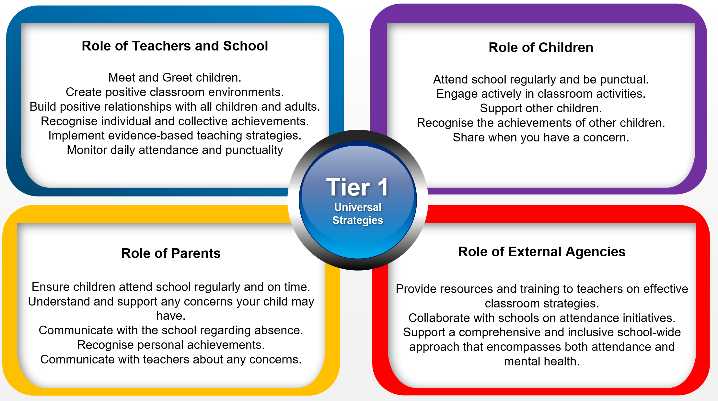

Tier 2 - Individualised Strategies and Early Help Support: Tailoring strategies to individual needs and providing early help support for persistent attendance challenges.

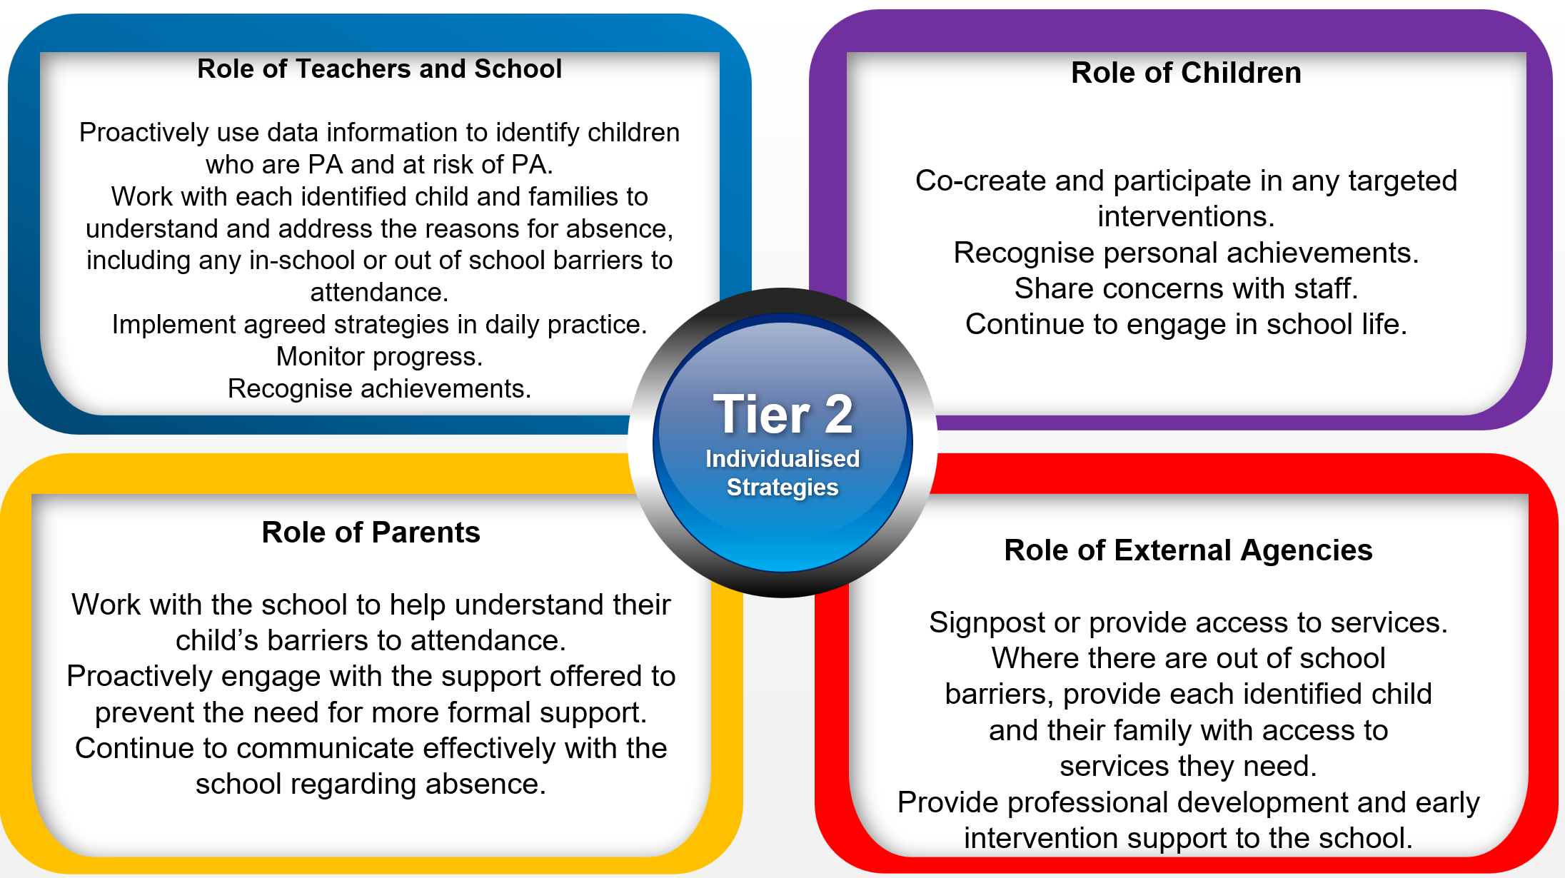

Tier 3 - Higher Needs Strategies Support: Furnishing specialised support for children, young people, and families with complex attendance requirements, including access to external agency support when necessary.

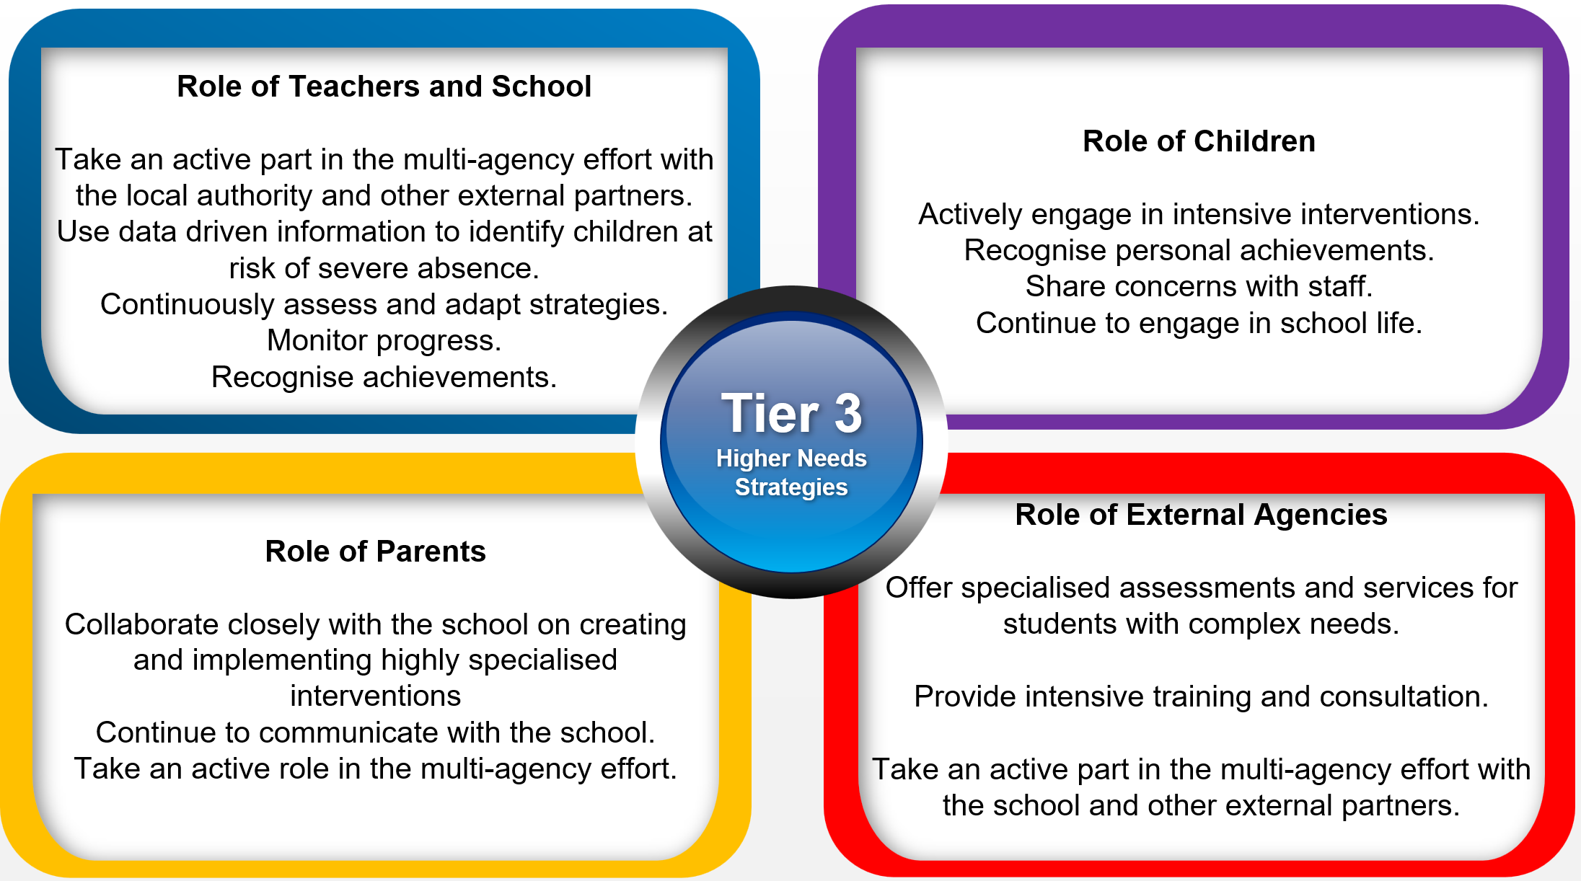

Recognition-Based Approach
Our attendance philosophy is rooted in a recognition-based approach that recognises both personal and collective achievements. This approach serves to thwart isolation, prevent victimisation, cultivate positive environments, nurture relationships, foster inclusivity, and ultimately cultivate intrinsic motivation among our children, families, and staff.
We focus on a universal offer:

- End of term pizza parties for winning class in phase.
- Attendance class data shared on every classroom door and in assembly.
- Attendance reward table hosted by SLT for children who have attended 100% the week prior.
- Attendance certificates and pencil or badge at weekly WOW assemblies.
- Class ‘Attendance Ambassador’.

The Importance of School Attendance

School attendance is not merely a requirement but a fundamental pillar of education. It plays a pivotal role in shaping academic success, personal growth, and future prospects, making it an indispensable aspect of any educational system.

- Academic Achievement: Regular attendance directly correlates with academic success. Children who attend school consistently are more likely to keep up with the curriculum, perform better in exams, and improve their life outcomes.
- Knowledge Acquisition: School is where children acquire knowledge and skills that are crucial for their personal and professional growth. Missing days means missing out on valuable learning opportunities.
- Social Development: School provides a vital social environment for children and adolescents to interact with peers, develop friendships, and learn essential social skills. Consistent attendance ensures children remain connected to their peer group.
- Building Routine: School attendance establishes a structured routine in children’s lives, teaching them time management and responsibility, which are valuable life skills.
- Teacher Interaction: Regular attendance allows for meaningful teacher-child interactions. Teachers can provide personalised support, address questions, and assess individual progress more effectively when children attend regularly.
- Preventing Knowledge Gaps: Frequent absences can lead to significant knowledge gaps, making it challenging for children to catch up with missed lessons, potentially resulting in long-term academic struggles.
- School Engagement: Children who attend school regularly are more likely to engage in extracurricular activities, sports, and other enriching experiences that contribute to their overall development.
- Legal and Parental Responsibility: Parents or guardians are legally responsible for ensuring their child's regular school attendance. Failing to do so can lead to legal consequences.
- Community Well-being: High levels of school attendance contribute to the overall well-being of communities.

