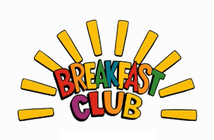

Dear Parents / Carers
I hope you are all well and in good health. We are delighted to announce the return of breakfast club this academic year. Breakfast club will begin the week commencing 13th September 2021 8:00am – 8:45am in hall 1 (Please enter through the main entrance on Corden Street)

At breakfast club your children will be served a healthy nutritious breakfast which will vary each day but will include: toast, yoghurt, cereal, fruit, pancakes, waffles and hot breakfast (Halal sausages, hash brown, beans and egg). Children will then get the chance to engage in fun physical activity and brain exercises to get ready for the school day ahead.

Breakfast club is open to all class children at Arboretum Primary School (Class 1 – Class 18). The cost for breakfast club is 50p per day which can be paid through our online facility or in cash daily / weekly.

If you receive FREE school meals for your child from Derby City Council due to your individual / family needs / circumstances then Breakfast club will be FREE for your children. (Please speak to office staff to apply for FREE school meals)

In order to book your children for breakfast club please fill in the slip below and hand in to your class teacher or Mr Malooq.

Yours Faithfully

Mr Malooq

Extended Schools Co ordinator
………………………………………………………………………………………………………………...

Child Name | Class | Parent name and contact number | Any allergies / food allergy

