
Safeguarding newsletter
Summer Term 2024

Welcome to the latest addition of our Safeguarding newsletter

We are happily back into the summer term after a fabulous 2 week break. It is so good to see all the children enjoying the little bit of sunshine that occasionally appears!

This newsletter will focus on Peer on Peer abuse, whether this means at school, home or even online.


Spotlight on:

- Peer on peer harm or abuse

Peer-on-peer abuse or harm is any form of physical, sexual, emotional and financial abuse, and coercive control, exercised between children, and within children’s relationships. This can include:

. Bullying, including cyberbullying, prejudice-based and discriminatory bullying.

. Physical abuse such as hitting, kicking, shaking, biting, hair pulling, or otherwise causing physical harm; this may include an online element which facilitates, threatens and/or encourages physical abuse

. Harmful sexual behaviours or sexual harassment, such as sexual comments, remarks, jokes and online sexual harassment, which may be standalone or part of a broader pattern of abuse.

. Causing someone to engage in sexual activity without consent, consensual and non-consensual sharing of nude and semi-nude images and or videos.

Downplaying certain behaviours, for example dismissing sexual harassment as “just banter”, “just having a laugh”, “part of growing up” or “boys being boys”; or not recognising that emotional bullying can sometimes be more damaging than physical harm and should be taken equally seriously, can lead to a culture of unacceptable behaviours and an unsafe environment for children therefore any form of peer on peer abuse is taken very seriously at Arboretum.

If you have any concerns about peer on peer harm or abuse, please speak to a member of the safeguarding team.

Spotlight on:

- Children’s Mental Health

Children’s Mental Health Week took place last half term with the theme of MY VOICE MATTERS.
It was set up by children’s mental health charity Place2Be and shines a spotlight on the importance of children and young people’s mental health.

In school we continue to support children’s’ wellbeing by having staff members training in Nurture, ELSA and Drawing and Talking. We are also supporting children who become dysregulated by opening up a safe space for them. At Arboretum we are lucky enough to have lots of staff trained in mental health and wellbeing who are able to offer bespoke sessions to suit needs of the individual child. Furthermore, we have recently opened up The Orchard to offer children a safe space throughout the day for them to access and get the regulation time they need.

We also have growing a pastoral team: See below our Pastoral team for summer term 2024.
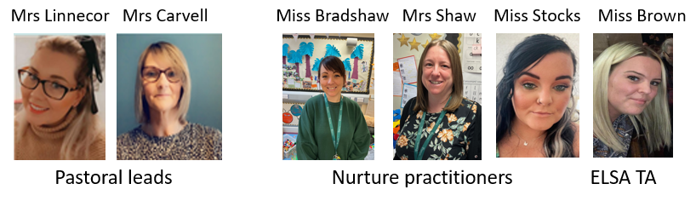

We are very proud of what we offer here but if you have any questions, please ask.

We can also signpost to external agencies such as Compass and Bridge the Gap.

Children’s mental health is very important to us but there is no “quick fix”; It takes a long time to support someone who is struggling, but our team will do their best to help.

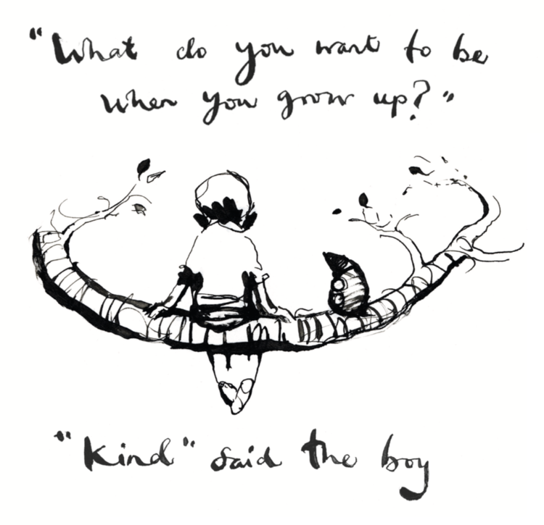
As always, If you have any concerns about a child, Please do not hesitate to contact the safeguarding team.
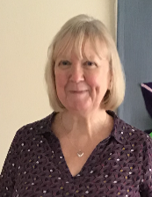

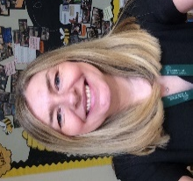





Mrs Phillips
Designated Safeguarding
Lead
Mrs Forster
Safeguarding
Governor

Mrs Roberts
Deputy Designated Safeguarding Lead
Mrs Darling
Deputy Designated Safeguarding Lead
Mrs Carvell
Deputy Designated Safeguarding Lead
Mrs Linnecor
Deputy Designated Safeguarding Lead
Mrs Ferguson
Deputy Designated Safeguarding Lead

