

Safeguarding Information for Visitors
Welcome to Arboretum Primary School
We want to ensure that our school provides a safe and enjoyable experience for everyone within it. We are committed to safeguarding and protecting all of our children and staff.
We ask you to read and adhere to the following information to help us keep you and our children safe.
At Arboretum, our children enjoy meeting new people so we hope that you find you are made to feel welcome by pupils as well as our staff. Please ensure that you wear your visitor badge at all times, otherwise you may be challenged.
In accordance with current safeguarding guidelines, visitors who are not able to present proof of a valid enhanced DBS disclosure will be escorted at all times on their visit. We appreciate your understanding of this protocol.
⇒ A copy of our Safeguarding and Child Protection Policy is available in the staffroom and on our website:
http://www.arboretum.derby.sch.uk/
The School’s safeguarding email is:
safeguarding@arboretum.derby.sch.uk

The School’s telephone number is
01332 291140
⇒ You are able to make referrals to Children’s Social Care if necessary, but you must always inform the DSL(Designated Safeguarding Lead) or DDSL (Deputy Designated Safeguarding Lead) as soon as possible after doing so.
Children’s Social Care First Response: 01332 641172
Out of Hours Careline: 01332 786968

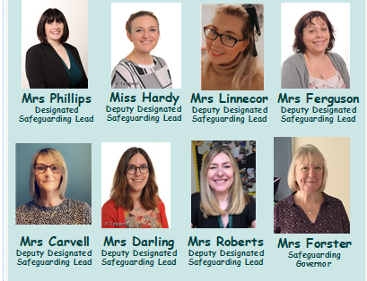
Our Safeguarding Team

If you have any concerns during your visit, they must be reported to the Designated Safeguarding Lead or Deputy Designated Safeguarding Leads immediately.

Our Senior Leadership Team
Head Teacher: Mrs Helen Phillips Deputy Head Teacher: Miss C Hardy
School Business Manager: Miss C Fryer Senior Phase Lead: Mrs S Ferguson
Chair of Governors: Mrs S Forster

Code of Conduct for Visitors
• No smoking anywhere on the school site
• Mobile phone use is restricted to the Staffroom, please ensure your mobile phone is switched off at all other times
• Adults must only use Staff toilet facilities
• NO NUTS OR NUT PRODUCTS ALLOWED IN SCHOOL
• Treat all of our children and staff equally with respect
• Ensure that all conversations you hear relating to children, staff or school business remain confidential
• Please do not use cameras or electronic devices in School
• Please ensure your visitor’s badge is visible at all times
• Inform a member of staff if you observe anything of concern

Emergency Procedures
• On hearing the Fire Alarm (a continuous tone) you should leave the school, following the Green FIRE EXIT signs and proceed to the Fire Assembly point on the playground
• DO NOT re-enter the building unless told by a senior member of staff that it is safe to do so

Accidents / Illness
Should you have an accident or feel unwell during your visit, please report to the main school office. If you are unable to make your own way to the office, please inform any member of staff about your situation.
You may be asked to complete an accident form; we would appreciate your co-operation in doing so.

Our School Code

At Arboretum Primary School we:

* Provide a safe, supportive, stimulating learning environment
* Are a team of respectful, tolerant, open minded citizens
* Are a community where everyone aspires to be the very best they can be
* Are a community of resilient, lifelong learners
* Are a centre of excellence where all achieve success



Supportive Team Player Aspirational Resilient Successful

