Special Educational Needs and Disability
Information Report
November 2025




Our Vision
We believe that for our children to compete at their highest level, we must guide them to ‘reach for the stars’; providing them with the knowledge and skills to be sensational both now and in their future.

S - Safe
T - Tenacious
A - Ambitious
R - Respectful
S - Sensational
We want our children to know they can be what they want to be – there are no limitations!

Special Educational Needs
Definitions of special education needs taken from SEND Code of Practice 2014

“A young person has SEN if they have a learning difficulty or disability which calls for special educational provision to be made for him or her. Children and young people who have SEN may also have a disability under the Equality Act 2010. Where a young person is covered by SEN and disability legislation, reasonable adjustments and access arrangements should be considered as part of the SEN planning and review.”

Ordinarily Available Provision
High Quality Inclusive Teaching
This includes:
- Ensuring the classroom environment promotes high expectations.
- Learning is chunked, ensuring new learning builds upon prior learning.
- Adapting teaching to support cognitive working memory and to prevent overload.
- Developing key skills and ensuring learning is represented in different ways.
- Ensuring key resources and equipment are available to support learning and independence.
- Putting specific strategies/ adaptations in place to support pupils with their access to learning.
- Checking progress and attainment and adapting learning accordingly.
- Celebrating everyone’s achievements and promoting a positive, supportive learning environment.
- Ensuring the total communication approach is embedded across the school.
- Ensuring learning materials are clear, concise and contain useful visuals to support learning.
- Using Widgit symbols, visual timetables, now and next to support communication and understanding.
- Scaffolding learning through working walls to support independence in learning.
- Considering children’s starting points and grouping for Little Wandle Phonics and Maths.

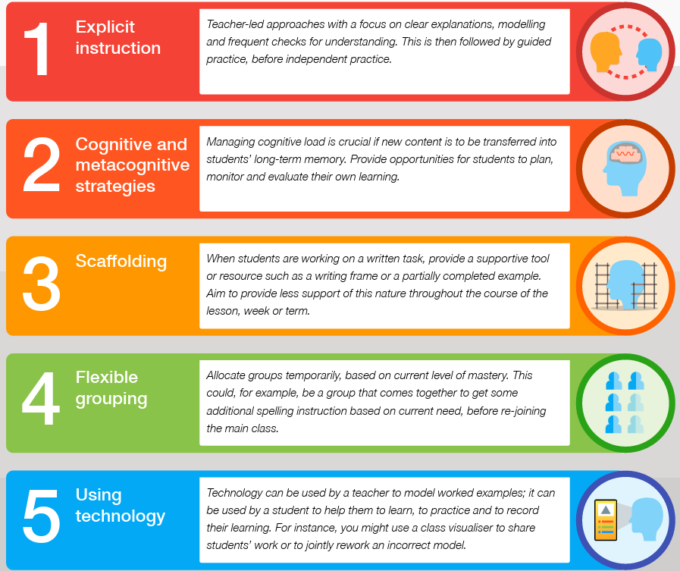

Group Interventions:
Interventions may be implemented to support specific learning needs. These groups are led by the teacher or teaching assistant (TA), they may include pre-teaching opportunities, additional support reflecting on prior learning and group work based on social, emotional support. We offer interventions such as Physical Literacy, Active Hands are Achieving Hands, LEGO Therapy, Zones of Regulation, Speech and Language and Attention Autism.

Individualised support:
This support is tailored to meet children’s primary area of need (PAN) and usually for those with more complex needs or disabilities. This may include a bespoke intervention for reading, phonics or maths. We also provide ELSA (Emotional Literacy Support Assistants), HOPE, Drawing and Talking and Forest School.

Supporting looked after pupils with Special Educational Needs (SEND)
In addition to the above, meetings are held for children who are looked after by the local authority and all special educational needs will be identified on their Personal Education Plans (PEPs). Looked after (LAC) and Post looked after (PLAC) children will still have an IEP outlining the child’s strengths, needs and SMART targets. The view of the child is always captured and reviewed termly.

Online Safety
Pupils with SEND needs can be particularly vulnerable when it comes to accessing the online world safely. As part of our curriculum offer we ensure that lessons are adapted, taking into account pupils age and aptitude. Our lessons follow the Project Evolve Curriculum and adaptations are made to support pupils with additional needs to understand the content of the lesson. We use visuals and scenarios to ensure understanding.
Sexual Violence and Harassment
At school we use the JIGSAW scheme for PSHCE; these lessons support children to understand how to build strong, respectful relationships with those around them. We learn about friendship, how to be a good friend and what to do when difficulties arise with friends. Our school rules ‘Ready, Respectful and Safe’ ensure that the message is clear about how we interact with those around us. Annually we use the NSPCC Speak Out materials and we deliver the NSPCC message of PANTS are private at least termly. The children know how to access support from our safeguarding team.
Four main types of Special Educational Needs
Communication and Interaction
Children and young people with speech, language and communication needs (SLCN) have difficulty in communicating with others. This may be because they have difficulty saying what they want to, understanding what is being said to them or they do not understand or use social rules of communication. The profile for every child with SLCN is different and their needs may change over time. Children with Autism are likely to have particular difficulties with social interaction. They may also experience difficulties with language, communication, social interaction and imagination, which can impact on how they relate to others.
Cognition and Learning
Support for learning difficulties may be required when children and young people learn at a slower pace than their peers, even with appropriate differentiation. Learning difficulties cover a wide range of needs, Specific learning difficulties (SpLD), affect one or more specific aspects of learning. This encompasses a range of conditions such as dyslexia, dyscalculia and dyspraxia.
Social, Emotional and Mental Health (SEMH)
Children and young people may experience a wide range of social and emotional difficulties which manifest themselves in many ways. These may include becoming withdrawn or isolated, as well as displaying challenging, disruptive or disturbing behaviour. These behaviours may reflect underlying mental health difficulties such as anxiety or depression, self-harming, eating disorders or physical symptoms that are medically unexplained. Other children and young people may have disorders such as attention deficit disorder, attention deficit hyperactive disorder (ADHD) or attachment disorder.
Sensory and or Physical Needs
Some children require special educational provision because they have a disability which prevents or hinders them from making use of the educational facilities generally provided. These difficulties can be age related and may fluctuate over time. Many children and young people with vision impairment (VI), hearing impairment (HI) or a multi-sensory impairment (MSI) will require specialist support and/or equipment to access their learning. Some children and young people with a physical disability (PD) require additional on-going support and equipment to access all the opportunities available to their peers.

Who are the best people to speak to in school about my child’s difficulties with learning/ Special Educational Needs or Disability (SEND)?
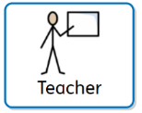
You can talk to your child’s class teacher they are responsible for:
- Checking on the progress of your child and identifying, planning and delivering any additional help your child may need to access learning.
- Completing Individual Education Plans and sharing and reviewing these with parents at least once each term and planning for the next term.
- Personalising teaching and learning for your child as identified on the school provision maps.
- Overseeing support that TAs and other adults within the classroom provide for your child.
- Ensuring that you are involved in supporting your child’s learning.

You can also talk our SENDCo, Mrs Cavanagh.
The SENDCo is responsible for:

- Developing and reviewing the school’s SEND graduated response.
- Co-ordinating all the support for children with special educational needs or disabilities (SEND).
- Providing specialist support for teachers and support staff in the school, so that they can support children with SEND in the school to achieve.
- Liaising with teachers/parents/carers to ensure that you are included in the Assess, Plan, Do, Review cycle.
- Monitoring the Individual Education Plans (IEPs).
- Liaising with all the other people who may be coming in to school to help support your child’s learning, e.g. Speech and Language Therapy, Educational Psychology.
- Maintaining the school’s SEND register.

SENDCo: Mrs Helen Cavanagh
Contact number: 013332 291140
Email address: senco@arboretum.derby.sch.uk


You can also talk to our Headteacher, Mrs Phillips.
Responsible for:
• The day to day management of all aspects of the school, including the support for children with SEND.
• Making sure that the Governing Body is kept up to date about issues relating to SEND.
• The Headteacher works closely with the SENDCo to understand the needs of the children with SEND, including the provision and resources that are needed.
Mrs Lyn Wynn is also available she is our SEND Governor.
As a member of the Local Trust Committee, she takes a special interest in SEND and meets with the SENDCo regularly throughout the academic year. The Local Trust Committee has overall responsibility for ensuring that the necessary support is given for any child who attends the school, and that appropriate support is provided for all SEND pupils.

Identifying children with Special Educational Needs and Assessing their Needs
Where there are concerns about a child’s progress, development or specific needs, the class teacher will always speak to the child’s parents/carers. The class teacher or supporting adult may also seek support and advice from the SENDCo. All initial concerns are documented and shared with the SENDCo who will agree strategies, interventions and class based support. The child will be monitored for at least a half term and their progress across the curriculum will be taken into consideration. Where necessary, pupils will be assessed using the Brackenfield small steps assessment system.

Individual Education Plan (IEP)

If concerns remain following a monitoring period then an Individual Education Plan (IEP) will be written. This will be written to include child views, parent views and will be strengths based. Specific, Measureable, Achievable, Realistic Time-bound (SMART) targets will be agreed. Provision will be put in place to support this process and these will be monitored termly. Once a child has an IEP, they will be added to the SEND register. All children with an IEP are monitored by the SENDCo and regular meetings will be held between teachers and parents/carers to review the IEP.
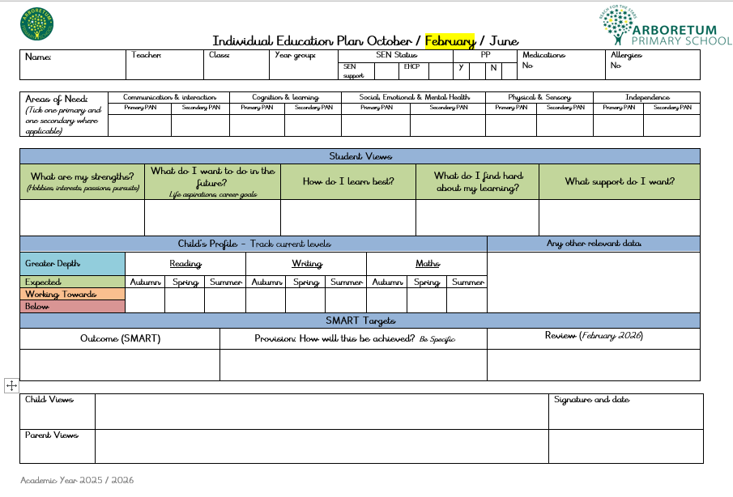

Graduated Response at Arboretum

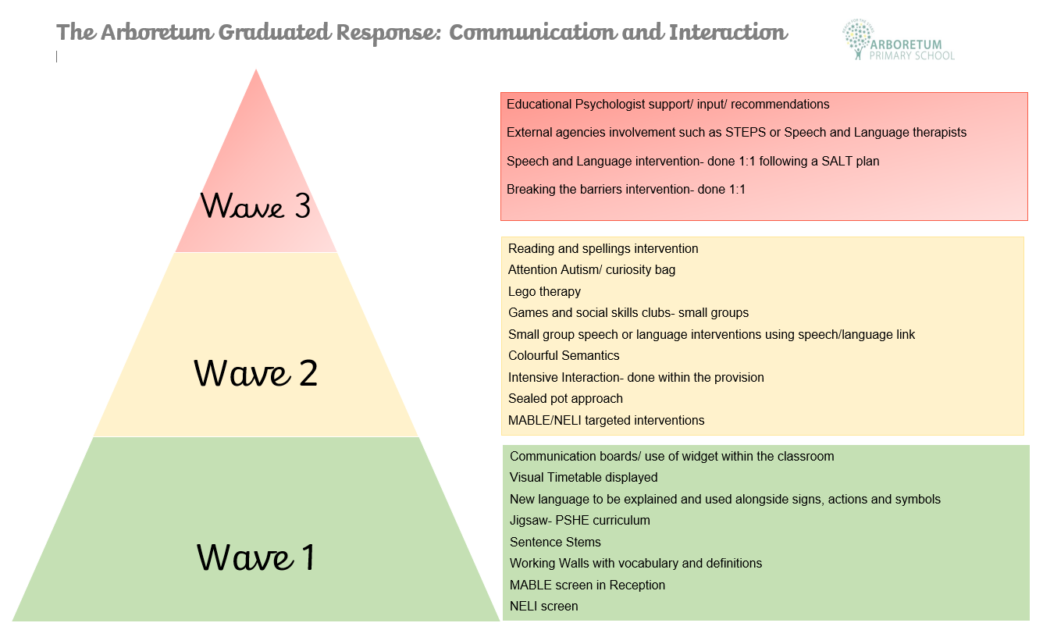

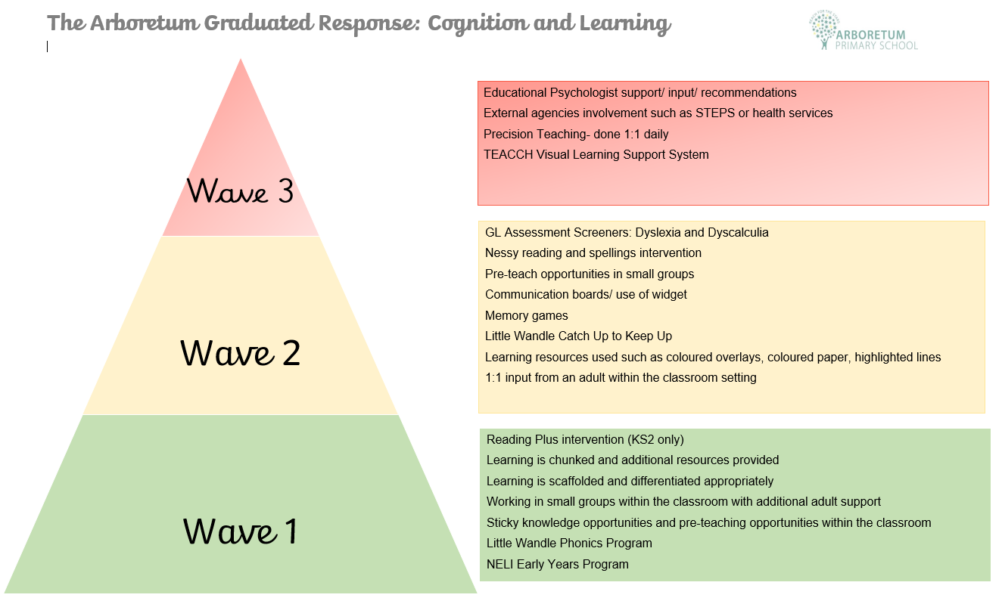

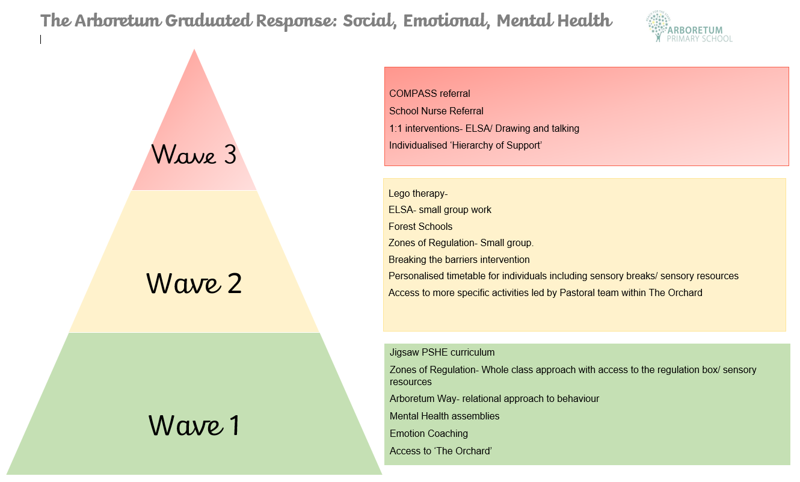

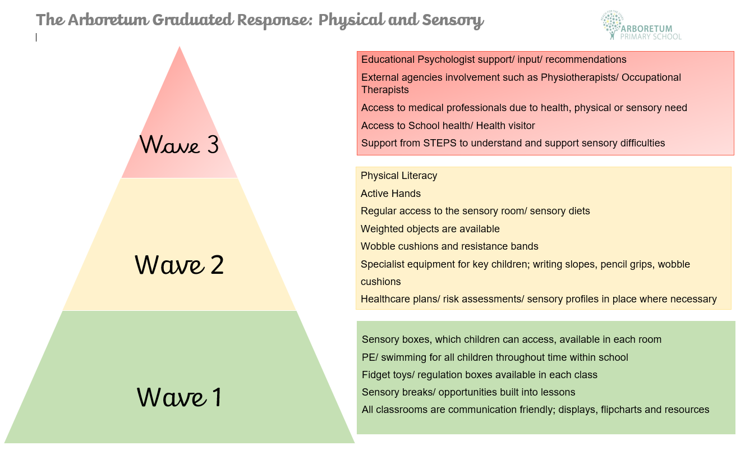

Specialist support/ External agencies
It may be that additional support is needed, this will be discussed with parents and consent obtained.
This may be from:
- Local Authority services, such as STePS (Specialist Teachers and Educational Psychology Services), which includes sensory support services such as, hearing or visual impairment specialist teachers, ASD specialist teachers and physical impairment specialist teachers.
- Health services such as, occupational therapists, physiotherapists and speech and language therapists.
Education, Health, Care Needs Assessment (EHCNA) request.

Where there are continued concerns about a child’s development or academic progress, an Educational, Health and Care Plan may be considered. This is a statutory assessment which is done with health and social care alongside the local authority. They will communicate with all agencies to decide whether an EHCP is needed to support the needs of your child. EHCPs are reviewed annually. A child must have an IEP for at least 2 cycles of APDR before an EHCNA can be requested. See below a flowchart showing the EHCP process:

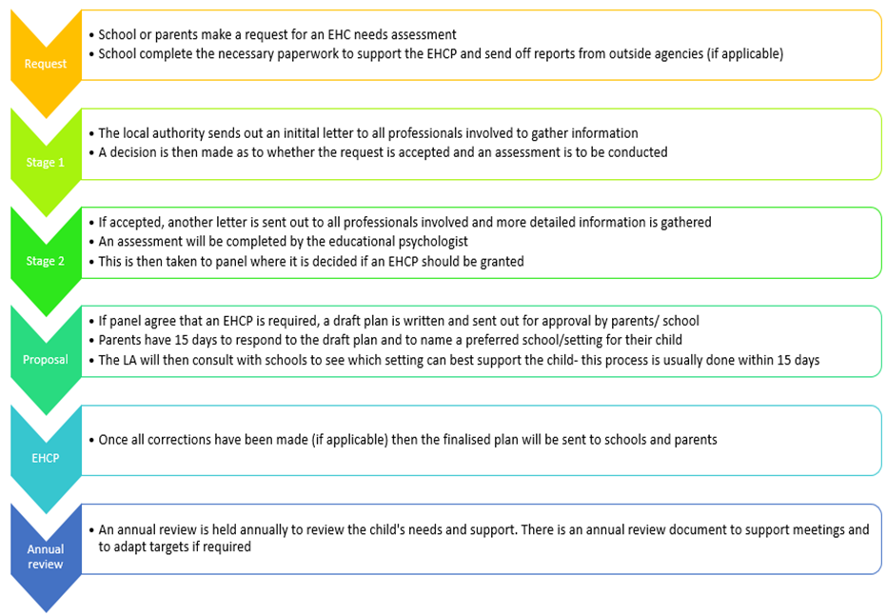

Support for children with Social, Emotional and Mental Health difficulties
Whole school approach
We aim to:
- Encourage the development of positive social relationships with both peers and adults.
- Provide opportunities to understand emotions and develop pupil’s self-worth, confidence, motivation, trust, self-esteem and adaptability.
- Provide a safe, calm and nurturing environment.
- Support pupils to understand their behaviours and to develop strategies to self-regulate emotions and anxieties.
- Support the development of a whole-school nurturing ethos focused on inclusion and positivity.
- Support with pupils experiencing emotionally, based school avoidance (EBSA)
The Orchard

The Orchard provides an environment which offers a safe, stimulating space for all children at Arboretum. The Orchard has been developed for the purpose of allowing children a space to self-regulate and develop their social and emotional skills. This room is a space away from the classroom environment where children can go to self- regulate with a trusted member of staff, this will help build positive relationships and will reduce the pressures and stresses placed upon them. There will be a range of resources available to help them develop their social skills, calming strategies and emotional awareness. Children are welcome within The Orchard throughout the whole day including break and lunchtimes.
Inclusion
All children across the school have the same opportunities to access the activities and clubs we offer. Where needed, those with SEND will be provided additional support and adults to enable them to access the club/ activities held across school. On site we currently have provision for pupils with high level needs who are not able to access the mainstream classes. Many of these pupils have Autism and associated communication and language difficulties. We are working closely with Derby City Council to ensure that these children access the right provision for their needs both now and in the future. Within this provision children have access to bespoke learning which supports different areas of need, enabling them to access the National Curriculum at different levels.
School provision:
- Class Teachers working with individual children or small groups
- Teaching Assistants working with individual children or small groups.
- Headteacher - Mrs Phillips
- Deputy Headteacher – Mrs Kay
- Assistant Head teacher and Behaviour lead – Mrs Ferguson
- Assistant Headteacher and SENDCo – Mrs Cavanagh
- Pastoral Manager - Mrs Carvell
- Pupil Support Officer - Miss Stocks
- ELSA teaching assistants - Miss Pearce, and Mrs Malooq
- Senior Mental Health Leads Mrs Carvell, Mrs Cavanagh
- Mental Health first aiders Mrs Malooq and Miss Stocks
- Play team offering support for children with emotional and social development needs on the playground
Local Authority:
- STePS (Specialist Teachers and Educational Psychology Services)
- STePs Intervention First Team
- Specialist teachers sensory support, support for children with visual or hearing needs
- Parent Partnership Service- SENDIASS
- SALT (Speech and Language Therapy)
- LAC (Looked After Children)
- Family Intervention Worker to support families
- Inclusive Attendance Team
- Family Hub
- Early Help Assessment
Health Provision:
- School Nurse
- Occupational Therapy – Lighthouse Team
- Physiotherapy – Lighthouse Team
- Community Paediatrician
- CAMHs (Child and Adult Mental Health services)
Training
Arboretum Primary strives to ensure staff members are well-trained and feel confident. All teachers are a teacher of SEND. All training is shared with others in the team. The SENDCo maintains a record of training attended and identifies further training needs.

How the effectiveness of the provision made for pupils with SEN is evaluated:
- Provision and strategies are monitored through:
- Observations and drop-ins
- Book scrutiny
- Tracking data using formative and summative assessments
- Reviewing interventions using post and pre assessments
- Discussions with teachers, TAs and parents
- Regular meetings to review IEPs
- Annual reviews to review EHCPs, targets and the provision identified in the plan
- Review meetings with necessary outside agencies

How is Arboretum Primary school accessible to children with SEND?
- The school is fully compliant with Disability Discrimination Act (DDA) requirements.
- The school is on one level with easy access and double doors.
- We have slopes outdoors in order for every child to access all areas.
- We have three accessible toilets, one with a hoist, one with a shower area and changing facility.
- We ensure, where ever possible, that equipment used is accessible to all children regardless of their needs.
- After-school provision is accessible to all children, including those with SEND.
- Extra-curricular activities are accessible for children with SEND.
- Simple adaptations have been made for specific needs e.g. organisation of classroom furniture for wheelchair users, specific seating arrangements for children who are hearing impaired or sight impaired.
- We have the support of the Physical Impairment Advisory Teachers via STePS and the Occupational and Physiotherapy Team should we require any specialised equipment e.g. sloping boards, tables, adapted chairs etc.

How will we support your child when they are joining the school?
Leaving the school? Or moving to another class?
We recognise that transitions can be difficult for a child with SEND, and we take steps to ensure that any transition is as smooth as possible.
If your child is joining us from another school:
- The SENDCo will visit pre-schools with the class teacher or Foundation Stage Leader where possible. Failing this, telephone conversations will be held to gather as much information as possible.
- All children joining our FS2 setting will have information shared on the Derby City online portal so key information will passed to teachers and key staff members.
- Social stories will be made with information about their current placement and their new school.
- Your child will be able to visit our school and have a look around.
- Parents will be invited to attend an information meeting when starting in our Foundation Stage and other year groups at the start of each term.
- You may be given an opportunity for additional visits to help to prepare your child for their move to the school depending on your child’s needs.
If your child is moving to another school:
- We will contact the school’s SENDCo and ensure they know about any special arrangements or support your child needs. Your child’s new SENDCo is very welcome to visit the school and observe and meet you child in school prior to moving on.
- We will make sure that all SEND records are passed on to the new school.
- Social stories can be made for them.
- The SENDCo and other key members of staff can support with visits to the school prior to the move.
When moving classes in school:
- Transition meetings take place every year and teachers exchange information and records.
- All children will have the opportunity to spend at least a day in their new class with key members of staff.
- Your child may be able to visit the new class more frequently where appropriate, to prepare them for the move.
- Social stories can be created to support children with the changes.
In Year 6:
- Transition meetings take place between secondary and Year 6 class teachers every year.
- The SENDCo will discuss the specific needs of your child with the SENDCo of the child’s secondary school. One Page Profiles can be shared at this point.
- Your child will participate in focused learning relating to transition through PSHE lessons.
- Your child will visit their new school and, if needed, additional sessions can be arranged as part of transition.
- In some cases staff from the new school will visit your child in this school
- Social stories can be created to explain the process and share photos/ key information about the new school.
- Pre-visits can be arranged when choosing secondary schools- these visits can be supported by SENDCo and other key staff members when required.
- The SENDCo and team are still available to support even after your child has moved on to their next placement.
What support do we have for you as a parent of a child with SEND?
- The class teacher is regularly available to discuss your child’s progress or any concerns you may have and to share information about what is working well at home and school, so that similar strategies can be used.
- The SENDCo is available to meet with you to discuss your child’s progress.
- All information from outside professionals will be discussed with you with the person involved directly, or where this is not possible, in a report.
- Additional support plans will be reviewed with your involvement at least termly.
- A home-school contact book may be used to support communication with you when this has been agreed to be useful for you and your child.
- Half termly coffee mornings
- Derby Family Hubs

- Derby SEND Information Advice and Support Service (SENDIASS) is available to give further impartial advice and support should you need it.
- Contact Details: www.derbysendiass.org.uk
Derby SENDIASS, The Council House, Corporation Street,
Derby, DE1 2FS
Phone: 01332 641414 or text 07800 005190
Facebook: @derbysendiass

Admissions of SEN pupils
If you would like your child to attend our setting or if you would like to discuss the support we can offer, please get in touch with the school’s SENDCo who can support you further.

If you are unsure on how to apply for a school place for your child, see below the admissions information needed through Derby City:

Telephone 01332 956988,
Email admissions@derby.gov.uk

If your child has an Education, Health and Care plan then you apply for your school place through Derby City’s EHCP team will work with you to choose your child’s school.
Please contact our EHCP team:
Telephone 01332 642425 or 01332 643616
Email SENDadmin@derby.gov.uk

Complaints procedure
Pupils, staff and parents are expected to listen carefully and respectfully to each other. Where an issue arises, parents should, in the first instance, make an appointment to speak with their child’s class teacher and seek to resolve any concerns. If a parent believes that their concern has not been resolved to their satisfaction or is of a more serious or sensitive nature, an appointment should be made to see the Headteacher who will investigate and report back on the results of the investigation. Where an issue is not satisfactorily resolved, parents should then take up the matter with the Chair of Governors.

If you still want to complain please see our complaints policy which can be found on the school website: http://www.arboretum.derby.sch.uk

Derby City Council Local Offer
The Children and Families Bill was enacted in September 2014. From this date Local Authorities (LA) and schools are required to publish and keep under review information about services they expect to be available for children and young people with special educational needs (SEN) aged 0-25. The Local Authority refer to this as the ‘Local
Offer’. The intention of the Local Offer is to improve choice and transparency for families. It will also be an important resource for parents in understanding the range of services and provision in the local area.
The Derby City Local Offer can be accessed here:

https://www.derby.gov.uk/education-and-learning/derbys-send-local-offer/

