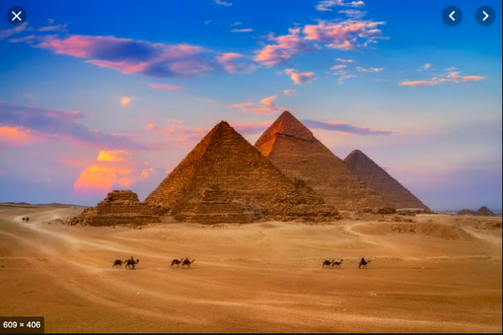
Hello from Year 3 and 4,
Each week your child will receive reading, spelling, and maths (times tables) homework. This homework sheet is designed for you and your child to get creative around our new topic.
Your child has until the Easter holiday to complete 5 of these projects. We’ll keep a track of how many you’ve done in class. Children’s achievements will be celebrated in school. Your child can use ICT to present their projects if they would like to.
Every week

Each week, you will need to read using ‘Reading Plus’.
You will need to practise your
weekly spellings to get a score of 7 out of 10 or more.
Use TT Rockstars to learn all
times tables.

Be a reader
The Egyptian Cinderella - Shirley Climo
Secrets of a Sun King - Emma Carroll
The Red Pyramid - Rick Riordan
The Story of Tutankhamun - Patricia Cleveland Peck & Isabel Greenberg
Egyptology; Search for the tomb of Osiris - Emily Sands
Be a designer
Have a go at mummifying something - not your family!
Design a shoe that would be fit to wear on the hot Egyptian Sands.
Design an Ancient Egyptian outfit.
Year 3 and 4
Spring Term
Ancient Egyptians
Be an artist
Find out about Hieroglyphics. Can you write your name?
Design a sarcophagus fit for a King or Queen.
Imagine you are a tourist seeing the pyramids for the first time, sketch or paint your view

Be an explorer
Imagine walking the length of the Nile. How many miles is this? What might you see along the way? Which towns would you pass through?
Imagine you stumble across an open tomb. What would you see inside? Write a diary entry of the day you discover it.
Visit Derby Museum and see the Mummified Egyptians for free!

Be a researcher
Find out how the Pyramids might have been built.
What is it like in Egypt today? Why might someone go to visit?
What was life like for a child in Ancient Egypt?
What did the Ancient Egyptians think about Cats?
Who was Howard Carter?

