

Welcome to APES

Arboretum
Primary
Emotional
Support

Your APES Mentors are:

Miss Stocks and Mrs Carvell have previously trained in ‘HOPE’ Helping Our Pupils Emotions- by Rachel Rayner
The work we do is the same but under a different name!
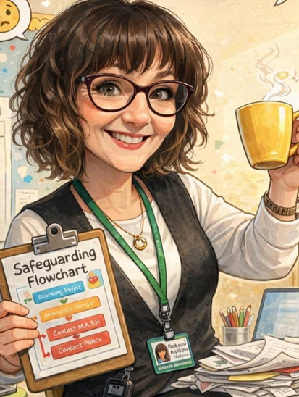
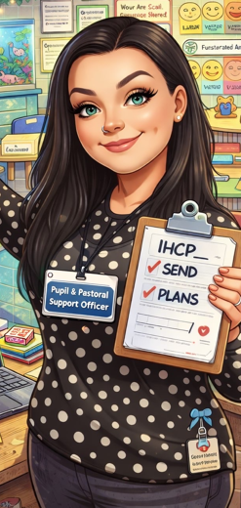

Mrs Carvell
Pastoral Manager
DDSL
Miss Stocks
Pupil and Pastoral Support Officer

Introduction 

As children learn and grow, it is normal for them to experience a range of feelings, including both happy times and more difficult moments. It is important that we validate all forms of feelings.
Sometimes, worries or challenges can affect a child’s confidence, emotional welfare, behaviour, or ability to enjoy school and everyday activities. This is often referred to as their emotional wellbeing.
For many children, these feelings pass with time with support from family and school. However, some children may need a little extra help to manage their emotions and behaviours to feel more settled and confident.

This leaflet explains the support that is available in school and what you and your child can expect from this intervention.

What is APES?
APES stands for Arboretum Primary Emotional Support. It is a school-based service that supports children and their families with emotional wellbeing.
APES provides early support through guidance, self-help strategies, and signposting to other services where needed. It is part of our whole-school approach to helping children feel happy, safe, and ready to learn.
Children may benefit from APES if they need someone to talk to or support with emotional, social, or behavioural difficulties. The aim is to help children feel more confident, settled, and able to manage their feelings.

How can APES help?
APES can offer support with a range of concerns, including:
- Family changes or difficulties that may be affecting your child’s wellbeing
- School refusal or avoidance
- Bullying
- Behavioural difficulties
- Anxiety or worries
- Sadness or low mood
- Low self-esteem
- Illness
- Bereavement
This is not an exhaustive list. If you have any concerns about your child, please speak to a member of the Pastoral Team, who will be happy to discuss how we can help.

Confidentiality

All information relating to support sessions are protected and treated with the greatest respect. As this is a school service, the Head Teacher and Class Teacher are normally consulted for further information relating to the child/young person’s difficulties.

Parent/Carers with parental responsibility will be informed of the service provided to their child/young person.

At times, and in exceptional circumstances, it may be necessary for certain information to be shared with other agencies, for example, if there are concerns around a child safety or safeguarding concerns.

What confidentiality information is shared with the child/ young person?

The children are told on the very first session about our confidentiality agreement which is as follows:
‘You can tell me anything you would like to and it’s confidential what you say to me, this means it is kept between us UNLESS I feel that you or someone else is at risk of harm or I need some support form a member of our schools safeguarding team’.

Where will the interventions be?

Meetings with the child will be in The Orchard in Miss Stocks intervention space. This is a private and confidential space that is only used by Miss Stocks.
Notes may be taken during the intervention which is filed away in the child’s personal folder.

Information about the sessions will not be shared with anyone unless this is deemed for the safety of the child.

How to we assess progress?
The children complete a ‘Me and my school questionnaire’ on the first session and again on the last session, this looks at emotions and behaviours.

The child also completes outcome rating scales which is completed every session which are:

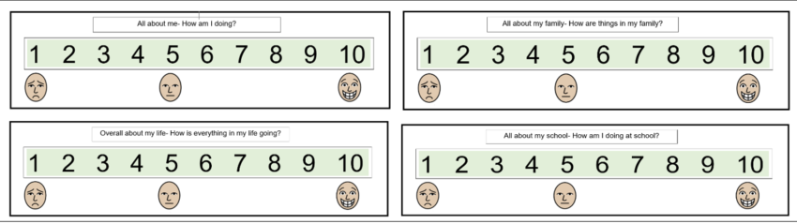

This assesses progress from week to week, during the sessions we expect this outcome rating scales to fluctuate.

This assesses progress from week to week, during the sessions we expect this outcome rating scales to fluctuate.

Who provides the service?

At school there is a team who support
Children and young people that includes the Head Teacher, SENCo, DSL Team and the Pastoral Team. There will be other people that help the service such as School Nurse, Parent/ Family Support Workers and Child & Adolescent Mental Health Service (CAMHS).
At Arboretum we have two trained APES Mentors who can deliver different interventions/ provide a listening ear to our children and families.

How does a child/ young person get referred to APES?

If you feel your child needs support from the APES mentors then please speak to the Pastoral Team –
Mrs Carvell and Miss Stocks.
After the initial conversation we will then ask the class teacher to fill in a referral to APES document. The APES Mentors will then sit down and work out an action plan.

What happens once your child is under APES?

Your child will spend some time with the Schools APES Mentor and work through targets to support. The main role of the APES mentor is to be an active listener. Interventions are adapted to meet the needs of the child.

How many sessions will the child/ young person need?

The number of sessions required depends on the problem and how the child and family engage. Typically, 5-8 sessions are enough to resolve difficulties in the early stage. The sessions will be reviewed and any decisions made will be shared and agreed with the people concerned.

Drop-ins may also be available for parents and young people for one-off advice.
For further information please check with the Pastoral Team.

Respecting needs

If any child, young person, parent/carer has difficulty reading, understanding, hearing
difficulties or has English as a second language; the school will endeavour to provide assistance to meet your needs.

Please let us know if you have any specific requirements.

