

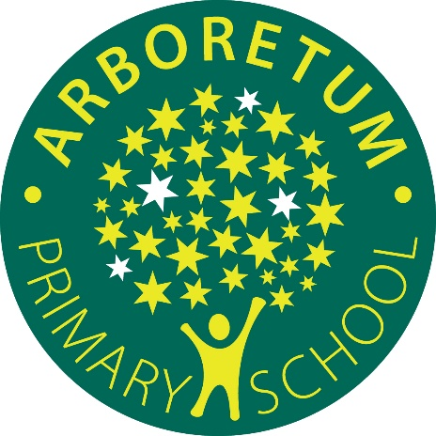

Allergy Management Policy
September 2026

Approved by the Trust Board on: 10th July 2026

Review date: June 2027

Table of Contents

1. Purpose and Legal Framework 3
2. Scope 3
2.1 Introduction 3
2.2 Key Definitions: 4
3. Key Statutory Requirements 4
4. Roles and Responsibilities 5
4.1 Trustees 5
4.2 Trust Central Team. 5
4.3 Head Teachers 5
4.4 Named Allergy Lead at (Arboretum Primary School is Mellisa Stocks) 5
4.5 All Staff 6
4.6 Parents/Carers 6
4.7 Pupils (where appropriate) 6
5. Identification and Management of Pupils with Allergies 6
5.1 Allergy Register 6
5.2 Individual Healthcare Plans (IHPs) 7
5.3 First Allergic Reaction in School 7
5.4 Pupils requiring additional support 7
6. Adrenaline Auto-Injectors (AAIs) 8
6.1 Stock AAIs (Spare Pens) 8
6.2 Personal AAIs 9
7. Training Requirements 9
7.1 Mandatory Training (All Staff) 9
8. Prevention and Risk Reduction 9
8.1 Catering and Allergen Management 10
8.2 Declared Allergens (PPDS Compliance) 10
8.3 Visitors and external providers 11
8.4 Curriculum Activities 11
8.5 School Trips and Residential 11
8.6 Exams 12
9. Emergency Response Procedure- CODE ORANGE 12
10. Incidents: recording, reporting and learning 13
11. Monitoring and Compliance 13
12. Policy Review 13
APPENDIX 1. Example Allergy Individual Health Care Plan 14

Purpose and Legal Framework
This policy sets out how all DDAT schools will meet their statutory duties to keep children with allergies safe, in accordance with:
- Benedict’s Law (2026); which requires all schools to have an allergy safety policy, to publish it via their school website, and to follow the statutory guidance.
- Supporting children and young people with medical conditions and allergy (DfE statutory guidance, effective Sept 2026); which stipulate the requirement for mandatory training, Individual Healthcare Plans, and emergency preparedness arrangements.
- Children and Families Act (2014)
- Equality Act (2010)
- KCSIE (2025/6)
- Health and Safety at Work Act (1974)
- Working Together to Safeguard Children (2026)
This allergy policy operates alongside our Supporting Children with Medical Needs and should be read in conjunction with that.
DDAT is committed to ensuring that no child is placed at avoidable risk and that all pupils with allergies are safe, included, and able to participate fully in school life. This includes making reasonable adjustments for pupils with SEND, communication needs, sensory needs, or developmental differences which may affect their ability to recognise, communicate, or manage allergic reactions independently.
This policy aims to ensure a consistent, Trust-wide approach to allergy management, reducing variation in practice and ensuring all pupils are protected to the same standard.

Scope
This policy covers:
- Food allergies and intolerances
- Insect sting allergies
- Medication allergies
- Medical dressing allergies
- Environmental allergies where risk of anaphylaxis exists
- The management of adrenaline auto-injectors (AAIs)
- Staff training and competency
- Emergency responses
- Recording, reporting, and learning from incidents
- Roles and responsibilities across the Trust
- Processes for managing a child’s first allergic reaction in school

2.1 Introduction
This policy sets out how Arboretum Primary School will support all pupils, staff and visitors with medical conditions, intolerances and allergies, in terms of both their physical and mental health, are supported. We aim to ensure that they are kept safe and included in taking part in there school life. The below definitions are taken from ‘Allergy Safety in Schools statutory guidance- July 2026.
At Arboretum Primary we believe in a whole team approach with a dedicated staff team that help keep children safe in school. We have a designated Allergy Lead- Mellisa Stocks who will coordinate Individual Health care Plans, co-ordinate meetings and support positive inclusion. (See 4.4)

2.2 Key Definitions:
- Allergy is a medical condition in which the body’s immune system has an abnormal reaction to normally harmless substances such as food, insect stings, contact allergens and airborne allergens.
- Anaphylaxis is a potentially fatal reaction affecting the Airway/Breathing/Circulation (“ABC”). Many individuals with allergies to food or insect stings are at risk of anaphylaxis.
- Asthma is a lung disease caused by inflammation and tightening of the airways, it is frequently associated with allergy and anaphylaxis, because exposure to allergens can provoke an asthma attack, a potentially life-threatening condition.
- Intolerance to foods or an ingredient that the body is unable to digest is different to allergy and does not cause a serious allergic reaction. It can cause long term health problems if not avoided. Common food intolerances include lactose and gluten.
- Coeliac Disease Coeliac disease is an autoimmune condition where the small intestine (gut) is hypersensitive to gluten in wheat and other gluten-containing grains (e.g. rye, barley). It is not an intolerance.

Key Statutory Requirements
All schools must:
- Stock spare AAIs for emergency use.
- Provide all staff with mandatory annual allergy awareness training, including:
  - recognising symptoms
  - emergency responses
  - administering AAIs
  - calling the emergency services
- Have a link from their website to the Trust website to ensure access to this policy
- Ensure Individual Healthcare Plans (IHPs) are in place for all pupils with diagnosed allergies.
- Record all allergic incidents, near misses, and AAI administrations.
- Conduct post-incident reviews and implement learning.
- Appoint a Named Allergy Lead in each school.
- Ensure safe practices in:
  - school meals and catering
  - curriculum activities
  - trips and residential visits
  - after-school clubs
  - exam arrangements
  - school events and celebration which involve food being brought into school
- Ensure pupils with allergies are not excluded from activities unless a risk assessment determines otherwise.
- Establish protocols for communication with staff
- Establish protocols for communication with parents
- Establish protocols for clear communication with catering providers
- Implement effective cleaning routines with regards to allergen management

Roles and Responsibilities

4.1 Trustees
- Approve the policy and ensure compliance with Benedict’s Law and statutory guidance.
- Receive annual assurance reports from the Trust central team regarding implementation and efficacy at school level.

4.2 Trust Central Team.

Oversight is with the Chief Operations Officer. Implementation by the Estates and Health and Safety Lead. Where appropriate work will be linked to the Trust Safeguarding Lead
- Oversees implementation across all schools.
- Provides model templates, training frameworks, and compliance audits.
- Ensures schools meet statutory requirements.
- Conduct formal annual compliance audits
- Ensure allergy management arrangements appropriately consider pupils with SEND and complex medical needs.
- Incorporate allergy management into safeguarding and/or SEND reviews
- Monitor training compliance through central reporting systems
- Review incident trends and escalate concerns to the Trust Board

4.3 Head Teachers
- Ensure full compliance with this policy.
- Appoint a Named Allergy Lead.
- Ensure pupil data and information regarding allergies is accurate, maintained and appropriately shared with staff.
- Ensure that all staff members are provided with information regarding allergic reactions and anaphylaxis, including staff training completion, recording and monitoring.
- Ensure AAIs are purchased, stored, checked, and monitored in accordance with this policy.
- Ensure the policy is published on the school website.
- Ensure supply staff are appropriately briefed.
- Ensure that parents are informed of their responsibilities in relation to their children’s allergies
- Ensure that catering staff are aware of pupils’ allergies and act in accordance with the school’s policies regarding food and hygiene, including this policy.

4.4 Named Allergy Lead at (Arboretum Primary School is Mellisa Stocks)
- Maintains a register of pupil allergies and updates this in accordance with children’s IHP’s.
- Coordinates IHPs and annual reviews ensuring up to date medical information.
- Leads risk assessments and staff briefings.
- Ensure risk assessments and support arrangements appropriately reflect pupils’ SEND, communication, sensory, behavioural, or developmental needs.
- Oversees storage, expiry checks, and accessibility of AAIs.
- Leads incident reviews and reports to SLT and the Trust regarding incidents, near misses and lesson learned processes.
- Responding immediately and appropriately in the event of a medical emergency.
- Attending relevant training regarding allergens and anaphylaxis.

4.5 All Staff
Complete mandatory training which ensures that they:
- Know how to recognise an allergic reaction.
- Understand that some pupils with SEND may present distress, dysregulation, shutdown, or behavioural changes rather than typical verbal reporting of symptoms
- Know the location of AAIs and how to administer them.
- Know how to follow IHPs and risk assessments.
- Report concerns or incidents immediately, after the event.

4.6 Parents/Carers
- Provide medical evidence and updated information for their child and consent to this information being shared with school staff.
- Supply prescribed AAIs for their child and provide written consent for the use of these, and if required for the use of school held spare AAIs.
- Work with the school to develop and review IHPs
- Receive feedback from the school following incidents to inform learning and improvements
- Raise any concerns they may have about the management of their child allergies with the classroom teacher/school allergy lead.

4.7 Pupils (where appropriate)
- Participate in age-appropriate education about allergy safety.
- Follow safety rules and report symptoms promptly.
- Ensure they do not exchange food with other pupils.
- Notify a member of staff immediately in the event they believe they are having an allergic reaction, or have come into contact with an allergen.

Identification and Management of Pupils with Allergies

5.1 Allergy Register
Each school must maintain an up-to-date allergy register including details of:
- pupil name, year group/class, photo
- allergens
- severity of allergy and reactions
- symptoms
- prescribed medication
- location of personal AAIs
- expiry dates
- IHP review date
The register must be accessible to all staff (including supply staff).
Each school must maintain a single, centralised system for recording allergy information, incidents, and AAI usage, ensuring consistency and accessibility for staff.

5.2 Individual Healthcare Plans (IHPs)
IHPs must:
- be completed within 5 school days of notification
- include an Allergy Management Plan
- specify emergency procedures
- include pupil photo and parent/carer contact details
- be reviewed at least annually or after any incident
- Include information shared by medical professionals such as GP, dieticians etc.
Where a pupil has an EHCP or SEND Support Plan, allergy management arrangements should align with wider support planning. Schools should involve relevant professionals, including SENDCOs and health professionals, where a pupil’s SEND impacts allergy management, communication, supervision, or safe eating.
Where a pupil experiences a first allergic reaction in school, an interim plan must be recorded the same day, with a full IHP completed within 5 school days.
See Appendix 1 for an example Allergy IHP.

5.3 First Allergic Reaction in School

Where a pupil experiences a suspected allergic reaction for the first time:
- Treat the situation as a medical emergency if symptoms indicate anaphylaxis
- Follow the Emergency Response Procedure
- Use a spare AAI where clinically indicated and permitted
- Contact emergency services immediately
- Inform parents/carers as soon as possible, and always on the same day
- Record the incident and implement an interim healthcare plan the same day
- Ensure medical advice is sought and a formal IHP is implemented within 5 school days

5.4 Pupils requiring additional support

Some pupils may require enhanced supervision or adapted procedures due to SEND, communication difficulties, sensory needs, behavioural needs, or developmental stage. Schools should consider reasonable adjustments. For example:
- visual or symbol-supported plans
- adapted communication methods
- supervised eating arrangements
- Additional adult supervision where risk assessments identify need.

At Arboretum we have a whole communication approach and use various communication aids. If a child/ adult is unable to verbally or physically communicate their needs we have a variety of communication aids can help. This is the main communication board that will be displayed in all high risk areas of the school.

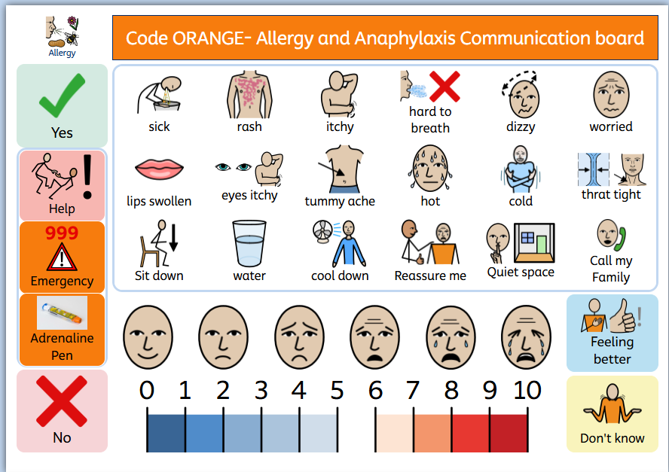

Adrenaline Auto-Injectors (AAIs)

6.1 Stock AAIs (Spare Pens)

Spare AAIs are held as an emergency backup only and do not replace pupils’ prescribed medication. Pupils with known allergies must continue to have access to their own prescribed AAIs in line with their Individual Healthcare Plan.

We have three locations where emergency Auto- Adrenaline Pens are kept. We have two Medical KITTs placed on our Lower KS2 Corridor, our next Medical KITT is located at the end of the Pastoral Corridor extending to Upper KS2 corridor. We also have additional Auto- Adrenaline pens that are used for trips, visits and residential.

All schools must:
- Hold at least two spare AAIs per key stage; this is minimum standard, schools may hold more based on individual risk assessments
- AAIs must be stored in clearly labelled, easily accessible, and unlocked locations, ensuring they can be retrieved immediately in an emergency and within a maximum of 5 minutes from any area of the school site.
- Ensure they are checked monthly
- Replace them before expiry
- Record all checks
- AAIs must be stored at room temperature in accordance with manufacturer guidance and not exposed to extreme heat or cold.

6.2 Personal AAIs
- Pupils must have two in-date AAIs in school.
- Personal AAIs must always be accessible
- Schools must have a system for monitoring expiry dates.
- Pupils may carry their own AAIs if appropriate (secondary settings).
- Personal AAIs must be accessible at all times and within a maximum of 5 minutes.

Please note: Spare AAIs may be used in line with statutory guidance, including for pupils not previously diagnosed but believed to be experiencing anaphylaxis.

Training Requirements
Training must include an element of practical demonstration or simulation, and schools must ensure staff are competent in administering AAIs, not just recorded as having attended training. Schools must ensure that staff are competent in recognising and responding to allergic reactions, including the administration of AAIs. Training should include awareness that pupils with SEND may communicate symptoms differently or present atypically during allergic reactions Training records must demonstrate both attendance and competence.

7.1 Mandatory Training (All Staff)
Annual training must cover:
- recognising mild, moderate, and severe allergic reactions
- anaphylaxis response
- administering AAIs
- calling emergency services
- safe supervision during meals, clubs, and trips
- incident reporting
Training must be completed:
- within 2 weeks of joining the school
- annually thereafter
- after any significant incident

Prevention and Risk Reduction
Schools must ensure that any food brought onto site by visitors, parents, or external providers is managed in line with the school’s allergy procedures. Clear communication must be provided in advance of events involving food.
At Arboretum School we are an ‘Allergy Aware’ School a regular reminder is sent out to parents and carers about what a healthy packed lunch should look like. This includes information on Allergy safety for all children.
Food that is brought into school for cooking/ food technology lessons, science experiments, D.T materials, celebrations that involve food. This should be purchased through the kitchen and liaised with the Catering Manager, Schools Business Manager and the Schools Allergy lead. If this is not achievable a risk assessment should be completed and agreed by the Allergy lead, School Business Manager and/or the Head Teacher before purchase.

Celebrations
At Arboretum Primary School, we aim to ensure that all celebrations are safe and inclusive for every child, particularly those with food allergies. Food-based celebrations will not be consumed in school. Any food items will be handed directly to parents or carers, items will need to be individually wrapped and clearly display the full list of ingredients allowing them to make an informed decision about whether their child can safely consume them. We actively encourage non-food celebrations, such as pencils, stickers or other small treats, to ensure that all children can take part safely and inclusively.

8.1 Catering and Allergen Management

Schools must implement robust procedures to ensure the safe handling of food and management of allergens. Schools must implement and maintain the Trust-approved allergen risk assessment template (e.g. YMD Boon) to identify, assess and manage risks associated with allergen handling and food provision. Please see ‘DDAT Food Policy’ for more information on procedures of safe handling of food in the kitchen.

This includes:
- All allergen information must be obtained from the supplier and recorded at the point of delivery within a centrally maintained food allergen log
- Allergen tracking must be maintained throughout the entire food preparation process, including storage, handling, preparation, cooking, and serving
- The food allergen log must be reviewed weekly by the kitchen manager to ensure accuracy and completeness
- Any incidents involving incorrect allergen information, unsafe practices, or incomplete packaging must be recorded in an incident log and managed appropriately by the kitchen manager

8.2 Declared Allergens (PPDS Compliance)

The following allergens must be clearly declared on all pre-packed for direct sale (PPDS) food items in a clear and legible format:
- Cereals containing gluten (e.g. wheat, rye, barley, spelt)
- Crustaceans (e.g. prawns, crab, lobster)
- Eggs
- Fish
- Peanuts
- Soybeans
- Milk
- Nuts (e.g. almonds, hazelnuts, walnuts, cashews, pecans, Brazil nuts, pistachios)
- Celery
- Mustard
- Sesame seeds
- Sulphur dioxide and sulphites (at concentrations above 10mg/kg or 10mg/L)
- Lupin
- Molluscs (e.g. mussels, oysters, squid, snails)

This requirement applies to all foods prepared on-site and pre-packed prior to sale or consumption, including (but not limited to) sandwiches, salads, and baked goods.

8.3 Visitors and external providers

The Head Teacher remains accountable for allergen safety even when catering is outsourced, therefore there is a requirement for written allergen assurance from catering and food providers.

Schools must ensure that:
- Visitors bringing food onto site are made aware of allergy protocols
- External providers (e.g. catering, clubs) comply with school allergy procedures
- Risk assessments are completed where outside organisations operate on site
Schools must:
- work with catering providers to ensure allergen-safe menus
- ensure allergen information is displayed and accurate
- prevent cross-contamination
- implement robust processes for managing meals provided to pupils with allergies
- ensure stringent supervision of lunch halls, packed lunch areas and pupil self-service locations
Schools must ensure that catering providers (including external contractors) comply fully with these requirements.

8.4 Curriculum Activities
Risk assessments must be completed, as required, for:
- cooking/food technology lessons
- science experiments
- art/DT materials
- outdoor learning
- celebrations involving food
All food and supplies must be ordered through the kitchen, if this is not possible a clear risk assessment should be completed and checked and agreed by the Allergy Lead, School Business Manager and/or Head Teacher before purchase.

8.5 School Trips and Residential
- Pre-trip risk assessments must include allergy management and all activities on the school trip will be risk assessed to see if they pose a threat to any pupils with allergies and alternative activities will be planned where necessary to ensure the pupils are included.
- Risk assessments should consider any additional supervision, communication, sensory, or behavioural support required for pupils with SEND.
- Staff must carry spare and personal AAIs and a member of staff will be assigned with responsibility for ensuring that the pupils’ medication is always carried throughout the trip.
- Spare and personal AAIs taken on trips and residential must always be accessible, not locked away.
- Venues must be contacted in advance regarding allergens and ensure the appropriate food can be catered for to ensure compliance with pupil’s food allergies

8.6 Exams
- Pupils must have access to medication.
- Invigilators must be briefed and have access to IHPs.

Emergency Response Procedure- CODE ORANGE
(Signs of an allergic reaction/ anaphylaxis)
When a pupil shows signs of an allergic reaction:
- Recognise symptoms (mild → severe).
- Staff should be aware that some pupils may present behavioural distress, withdrawal, panic, or non-verbal signs rather than verbally reporting symptoms.
- Administer AAI immediately if anaphylaxis is suspected.
- Call 999 and state “anaphylaxis”.
- Lie the pupil flat with legs raised, or in a position of greatest comfort if breathing is difficult; do not allow them to stand or walk
- Remove the allergen where possible and loosen tight clothing if possible
- Administer second AAI after 5 minutes if symptoms persist.
- Stay with the pupil, monitor breathing, and prepare for CPR if needed.
- Inform parents/carers as soon as possible, and always on the same day
- Record the incident and complete a post-incident review.
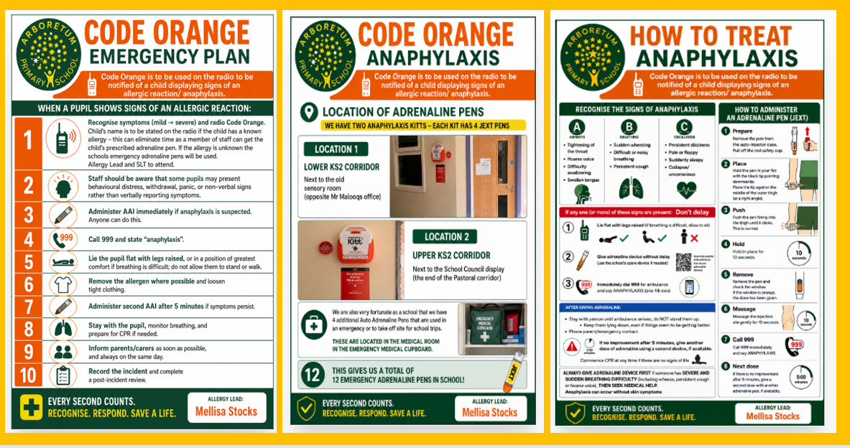
Schools will ensure a printed emergency action plan is displayed in key areas (for example: medical room, dining hall, staff room).

Incidents: recording, reporting and learning
Schools must:
- record all allergic reactions, near misses, and administration of AAIs
- report serious incidents to the Trust, this includes pupil hospitalisation, multiple use of AAIs for the same pupil, near misses, or concerns about staff practice, which must be escalated to the Trust within 24 hours
- conduct a lessons-learnt process within 5 school days
- update IHPs and risk assessments
- share learning with staff, Local Trust Committee and the Trust central team
- revisit staff training as appropriate, for all or some staff

Monitoring and Compliance
The Trust will:
- conduct annual compliance audits
- review allergy management processes including reasonable adjustments and SEND-related provision, through safeguarding and/or SEND review processes
- Monitor staff training compliance centrally
- Analyse incident data and escalate risks
- ensure each school publishes its allergy policy via the school website
- report to the Trust Board annually
Schools will:
- complete a termly self-audit
- ensure all documentation is up to date
- ensure staff training is up to date
- complete spot checks during high-risk times (lunchtimes, clubs).

Policy Review
This policy will be reviewed:
- annually
- following any serious incident
- following updates to statutory guidance
- following changes to Benedict’s Law regulations (Benedict’s Law gives the Secretary of State powers to make further regulations on allergy safety; this policy will therefore be updated accordingly)
- following DfE amendments to the statutory guidance

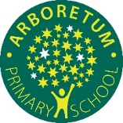
APPENDIX 1. Example Allergy Individual Health Care Plan

Arboretum Primary School
My name is:
I like to be called:
Individual Health Care Plan (IHCP) for an allergy- (state allergies)
D.O.B: |  | Class:
G.P Practice: |  | Class Teacher:
Emergency Contacts:

Mother:

Father:

My allergies are:

Level of severity:
Low | Moderate | High | Very High | Extreme

Does the child have understanding/ awareness on their allergies (can they alert others or use a communication board do they know and understand own allergies what they can and can’t have?)

How are the allergies presented:
Airborne | Ingestion | Direct Contact | Indirect Contact | Droplet Spread | Vector Borne | Blood Borne

Known triggers to avoid:

Medication:

Where my auto injector pens are stored:

Emergency adrenaline pens locations: Lower KS2 Corridor, Upper KS2 Corridor and Medial Room in the emergency medication cupboard
Other medical conditions or additional needs to be aware of:

Additional Arrangements/ Adaptations needed for School:
-Allergy placemats ___ not to be severed food without placemat
-All staff are allergy trained on how to spot signs and symptoms of allergies and anaphylaxis
Signs and symptoms (please highlight and explain further)
Withdrawn behaviour | Hoarseness cough
Continuous hard/ heavy breathing | Mouth or throat itching
Chest and neck heavy movements | Swelling on the lips, tongue, mouth or throat
Hunched over trying to catch breaths | Hives/ itchy rash or swelling to parts of the body
Nose opens wider | Nausea- abdominal cramps
Trouble walking or talking | Sickness or diarrhoea
Unable to complete or carry out an activity | Heart pulse- hard to detect
Lips, gums or fingernails turn grey, white or a darker colour | Skin turns blue or a lighter colour
Further information:

What my allergy looks like for me
  Green: Safe and well managed |   Amber: Watch closely |   Red- Emergency: ACT NOW!
- Breathing is normal  - Eating and drinking normal  - Showing no signs of allergy symptoms  - Able to carry out day-to-say tasks | - Hives, itchy rash or redness on skin  - Mild swelling (around eyes or lips)  - Stomach pain, nausea or vomiting  - Itchy mouth or throat  Becoming distressed/ uncomfortable | Signs of severe allergic reaction- anaphylaxis  - Trouble breathing, wheezing or noisy deep breathing  - Swelling of lips, tongue, throat or face  - Skin becomes pale, clammy or grey  - Child becomes floppy, confused or unusually sleepy  - Child collapses or faints  - Severe difficulty swallowing  - Serious reaction affecting more than one part of the body i.e. rash and breathing difficulties
Action | Action | Action
- Maintain allergy precautions | - Stop exposure to the suspected allergen  - Monitor the child on n a 1:1 for minimum 30 minutes- by Allergy Lead/ SLT  - Give prescribed allergy medication_____________  - If symptoms don’t improve seek medical advice- 999 | - Use the child’s prescribed emergency medication- following the steps below  - Call 999- state anaphylaxis  - DO NOT leave the child alone

Have any Health Care professionals issued any care or action plans: | YES/ NO
If Yes are the Care/ Action Plans attached: | YES/NO

Visits, trips and residential information:

What are the steps to help me when I am having an Allergic reaction/ Anaphylxais and the care I need:
Step 1- CODE ORANGE should be radioed stating my name and location- Allergy Lead and SLT to attend.
Step 2- First aider to identify if I need antihistamine or Auto injector.
Step 3- If antihistamine is needed administer ________ at ______, continue to monitor me very closely if symptoms show signs of anaphylaxis (Airways, Breathing and/ or Circulation) administer adrenaline pen straight away!
Step 4- Ensure that I am sat up right with my back straight or lay down with legs elevated.
Step 4- Call 999 state ANAPHYLAXIS explain that you are about to administer the auto injector pen and I have an allergy to ____, explain what I have eaten or come into contact with.
Step 5- Administer my auto injector pen how to do this:
- Form a fist around the epi pen
- Pull off the blue safety cap (this is the top)
- Position the orange end on the outer/ mid-thigh (needle side)
- This can be done through clothes or unclothed
- Jab the pen into the thigh at a 90 degree angle
- Hold in place for 10/15 seconds
- Remove epi pen
- The needle cover will automatically cover the needle
- Massage injected area for 10/15 seconds
- Epi pen to be discharged in to the sharps bin- located in the medical room
Step 6- My emergency contacts should be called and informed about my condition.
Step 7- Monitor how my symptoms are and if they don’t improve within 5 minutes administer second epi pen, following step 5 procedure again, or if directed by the paramedics.
Step 8- If possible stay on the phone to the emergency services to continue to update on my progress.
Step 9-If I am breathing but have become unconscious place me in the recovery position and monitor my air way, breathing and circulation. This MUST TO BE COMMUNICATED TO THE EMERGENCY SERVICES.
Step 10- If I have stopped breathing start CPR until the Paramedics are available to take over- this MUST BE COMMUNICATED TO THE EMERGENCY SERVICES. Defibrillator is located in the medical room.
If I am showing that I am feeling better after step 3 or my symptoms have reduced, my parents should be informed to come and collect me and seek a medical appointment the same day.
Plan written by:
Date
Plan developed with:

Review date for IHCP:
Plan copied to and signed by : |  | Signed | Date
Head Teacher:
Parent/ Carer:
SENCo:
Plan also shared with- Once read please sign and date: |  |  | Date
Class Teacher:
Class Teaching Assistant:

Other- State Name, Job Role

Consent form for use of emergency Adrenaline Auto Injector (AAIs)

I Parent/ Carer (insert full name)…………………………………………………….. Consent for Arboretum Primary School to use an emergency Adrenaline Auto Injector for my child (insert full name)………………………………………………….. D.O.B………………………………………..

Please sign that you agree
I confirm that my child has been diagnosed an allergy that requires a personal adrenaline auto injector.
My child has a working and in-date adrenaline auto injector that has the correct prescription label marked clearly. This will be kept in school at all times.
In the event of my child displaying an anaphylaxis shock and their adrenaline auto injector is un-usable or un- available. I consent for my child to receive an emergency adrenaline auto injector held by the school.
My Child doesn’t have a prescribed Auto- Adrenaline Injector pen however has known allergies. In the event of my child displaying symptoms of Anaphylaxis I consent to School using Schools Emergency Auto Injector.

Allergy Lead to date and sign acceptance Full Name: | Sign: | Date:

