Overview document – Changing me – Jigsaw – 2026 MATERIAL
Purpose: Review lesson material to ensure it follows PSHE progression document and is appropriate for our catchment.
Explain thought process for reference.
Lesson development: By Sarah Ferguson and Sally Bullock to ensure follows pro forma below.
From the PSHE progression grid document: -CHECK COMPLETE
Children are encouraged to think about how they have changed from being a baby and what may change for them in the future. They consolidate the names and functions of some of the main parts of the body and discuss how these have changed. They learn that our bodies change in lots of different ways as we get older. Children understand that change can bring about positive and negative feelings, and that sharing these can help. They also consider the role that memories can have in managing change.
Age 4-5 - 2026 materials | Lesson plan/preview amendments | Other comments
My body | 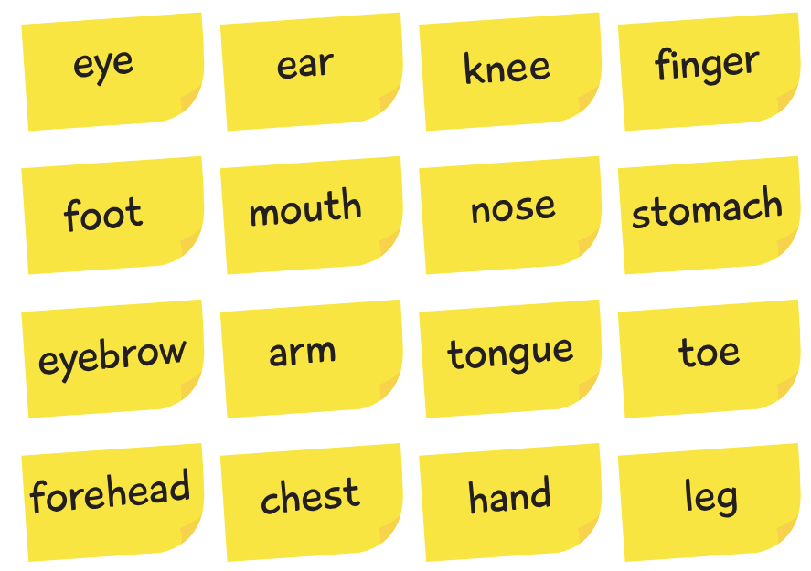 | No change to lesson content
Respecting my body | Healthy food choices | No change to lesson content
Growing up | We all grow from babies to adults. | No change to lesson content.
Fun and Fears Part 1 | Moving to a new class | No change to lesson content
Fun and Fears Part 2 | Continuation of above – moving to Year 1 | No change to lesson content
Celebration | Memory box – favourite things from the year. | No change to lesson content

From the PSHE progression grid document: CHECK COMPLETE
In this Puzzle, children learn about life cycles and the changes that happen as humans and animals grow. They reflect on how their own bodies have changed and develop understanding that everyone grows at different rates.
Across the six Pieces, children learn the correct names for private body parts, explore how boys’ and girls’ bodies can be different, and practise respecting their own bodies and those of others. They also think about feelings linked to change, such as excitement and worry, and learn ways to cope.
At the end of the Puzzle, children contribute their flowers of change work to the whole school Tree of Change display, celebrating growth, learning and new beginnings.
Age 5-6 - 2026 materials | Lesson plan/preview amendments | Other comments
Life cycles | No change
Changing me | No change
My changing body | No change
Boys’ and Girls’ bodies | NOT TAUGHT – this lesson is not taught as part of our curriculum  Year 1 DO NOT LEARN the names for other body parts such as penis, vagina, vulva, anus and testicles. | Do not include this lesson at Year 1.  An extra lesson if required could be written based on lesson prior or after.
Learning and growing | No change to lesson content.
Coping with changes | No change to lesson content.

From the PSHE progression grid document – CHECK COMPLETE
In this Puzzle, children explore life cycles in nature and how humans grow from young to old, learning that some changes are outside their control. They reflect on how their own bodies and independence change over time and develop respect for differences in themselves and others.
Across the six Pieces, children learn correct names for body parts, understand privacy, and practise being assertive about touch and personal boundaries. They also think about feelings linked to future change, such as excitement and worry, and learn ways to cope.
By the end of the Puzzle, children create Leaf Mobiles to celebrate growth and looking ahead.
Age 6-7 – 2026 materials | Lesson plan/preview amendments | Other comments
Life cycles in nature | No change to lesson content.
Growing from young to old | No change to lesson content.
The changing me | No change to lesson content – no need for ‘next lesson you will need…’ You will not require as the lesson is not taught.
Boy’s and girl’s bodies  From parent consultation on 10.5.24 parents expressed the wish they do not want their children taught the names of male and female genitalia – this has remained unchanged from May 2026 meeting to show lesson resources. | NOT TAUGHT – this lesson is not taught as part of our curriculum  Children in Year 2 are NOT taught the names for other body parts such as penis, vagina, vulva, anus and testicles.
Assertiveness | Important safeguarding lesson. | No change to lesson content.
Looking ahead | No change to lesson content.

From the PSHE progression grid document – CHECK COMPLETE
In this Puzzle, children learn how babies grow and explore the physical changes that happen to bodies as people grow up, including some inside and outside changes linked to puberty – see lesson detail below. They develop understanding of personal hygiene and why caring for their bodies becomes more important as they grow and change.
Across the six Pieces, children reflect on their feelings about change, learn correct vocabulary for body parts, challenge family stereotypes, and consider who they can ask for help if they feel worried. They also think about future transitions and how to cope with them.
By the end of the Puzzle, children create Ribbon Mobiles to celebrate growth and looking ahead.

Age 7–8 – 2026 materials | Lesson plan/preview amendments | Other comments
How babies grow  SF | No change  In mammals, the female has the baby. | For awareness – sexual orientation is ‘hinted at’:  Families come in all different shapes and sizes. Sometimes babies are cared for by two mums, two dads, grandparents, or other family members. What's important is that babies have adults who love and care for them.
Outside body changes  SB – use lesson developed separately by SB NOT Jigsaw lesson. | AMENDED LESSON TAUGHT – DO NOT USE JIGSAW RESOURCES  Some more graphic content here about external changes to the male and female body. See notes in next column about keeping changes referenced to those that are not related to genitalia and the pubic area (hair). | Discussion of changes such as:  Male – deep voice, broad chest and shoulders, hairy legs, facial hair, more muscular.  Female – we get hairier too! Under arms and legs.  Both sexes get taller, skin less smooth, may get spots, bigger feet.  Use above to change activity below:  Remove:  Growing pubic hair  Penis growing larger  Developing breasts
Inside body changes | NOT TAUGHT – this lesson is not taught as part of our curriculum
Keeping ourselves clean | New lesson about the importance of personal hygiene..  Positive new messages. Important to teach but with some modification. | 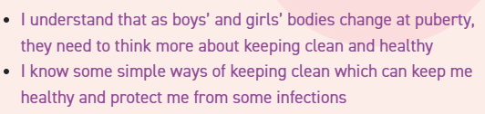  IALT slide will need to be amended – no mention of puberty.  Some slides will need to be amended as they refer to genitals and puberty. This should be amended to, ‘we need to wash the parts of our bodies that are under our pants’. Or ‘ We need to wash our private parts.’ This is the language that are children are familiar with.  SLIDES 8, 15, 16, 18 and 24 WILL NEED MODIFYING (Vulva, penis, genitals and puberty)
Family stereotypes  SF | No change to lesson content.  No change to lesson content. Teacher needs to consider any cultural sensitivities about what children view as appropriate gender jobs.
Looking ahead  SB | Slide 13 no reference to puberty in ‘Ask me this’.  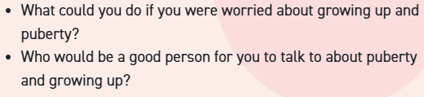Lesson is focused on moving to the next year group as per each end of puzzle lesson. | Remove reference to puberty in this lesson – all other questions on this slide about the half term’s learning can be used.
.
From the PSHE progression grid document – CHECK COMPLETE
In this Puzzle, children explore identity and what makes them unique while learning about physical and emotional changes linked to puberty, including menstruation. They consider the role of families, trusted adults, and inner circles in providing care and support.
Across the six Pieces, children develop strategies for coping with change, managing worries, and accepting things beyond their control. They practise reflecting on personal goals and positive changes they would like to make.
By the end of the Puzzle, children use Circles of Change to think about future transitions and celebrate growth and resilience.
Age 8–9 -2026 materials | Lesson plan/preview amendments | Other comments
Unique me  SB | No changes needed. | None but you will not be prepping the next lesson as suggested.
Puberty and menstruation | NOT TAUGHT – this lesson is not taught as part of our curriculum at this age group. | This is taught in Y5.
Being part of a family | 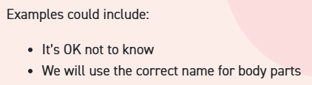  Slide 3 refers to correct name for body parts – we do not teach this until Y5.  Slide 8:  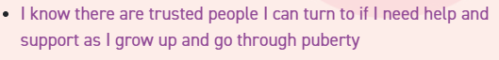  Vocabulary – Puberty – not mentioned.  Remove slides 15 -18 as they contain reference to puberty. | See left.  Puberty is not taught in Year 4.
Circles of change | Keep lesson however re-consider story that talks about change but is more relevant to their circumstances.  Amend story to a significant change more relevant to our catchment: Family living abroad that we don’t see very often/Hearing that a family relative living abroad is ill/Older brother or sister going to university.  One day after school, Sofia and Levi were called into the kitchen by their Dad who wanted a chat. Their Dad said he had met a new girlfriend and he wanted to get married to her. Their mum had left when they were little, so Dad had always looked after them on his own. Dad said his girlfriend was called Maria and she also had two children, so they would be one big happy family. Levi and Sofia weren’t so sure. They liked having Dad to themselves. Dad said he didn’t want to rush anything and said for now he just wanted them to get used to the idea and think about it for a while – CHANGE SCENARIO ON FLIPCHART DO NOT USE ONE ON SLIDES.
Accepting change | No changes.  Slide 19 makes reference to:  Sometimes young people also look for information online about growing up and the changes happening to them.  But only in the narration not in the slides. | Puberty is not taught in Year 4.
Looking ahead | No discussion of puberty at this phase.  Puberty is not mentioned on the slides but there are references in the planning that should not be mentioned.  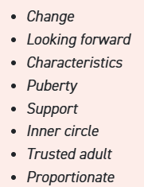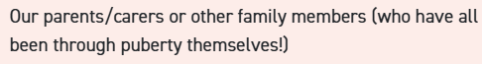  Ask me this contains questions about puberty. | Puberty is not taught in Year 4.
2a. Having a baby alternative  SF | I understand what responsibilities there are in parenthood and the joy it can bring.  I can consider what has influenced my life and what might influence the lives of other people.  I understand that having a baby is a personal choice and can express how I feel about having children when I am an adult.  This lesson is a general discussion about having children when you are older not the process of making a child or any associated language | No change to lesson content.
Relationships  Boyfriends and girlfriends | Lesson in Year 4 – this is moved to Year 6.

From the PSHE progression grid document – CHECK COMPLETE
In this Puzzle, children explore self-image and body confidence while learning about physical and emotional changes during puberty for girls and boys. They develop understanding of menstruation, male puberty, and how media influences perceptions of appearance and wellbeing.
This Puzzle includes one non-statutory sex education lesson where children learn about conception, fertility support, and how babies are made. (Moved to year 6). Across the six Pieces, pupils practise identifying trusted adults and reliable sources of information, alongside discussing responsibilities linked to growing up.
By the end of the Puzzle, children reflect on upcoming transitions using Circles of Change and consider how to manage feelings about future changes with confidence and resilience.
Age 9-10-2026 materials | Lesson plan/preview amendments | Other comments
Self-image and body image | No change to lesson content. Important life lesson.
Puberty for girls  SF | Teach menstruation in this Year 5 lesson.  DO NOT TEACH REPRODUCTION  USE LESSONS DEVELOPED BY PSHE COORDINATORS NOT JIGSAW MATERIALS.  1.5 hours –preferably an afternoon. | Lesson to be developed by PSHE coordinators.  Agreed videos to be added. We have not used the Jigsaw videos as they are unvoiced which allows the teacher to voice. Risk of inconsistency of message.  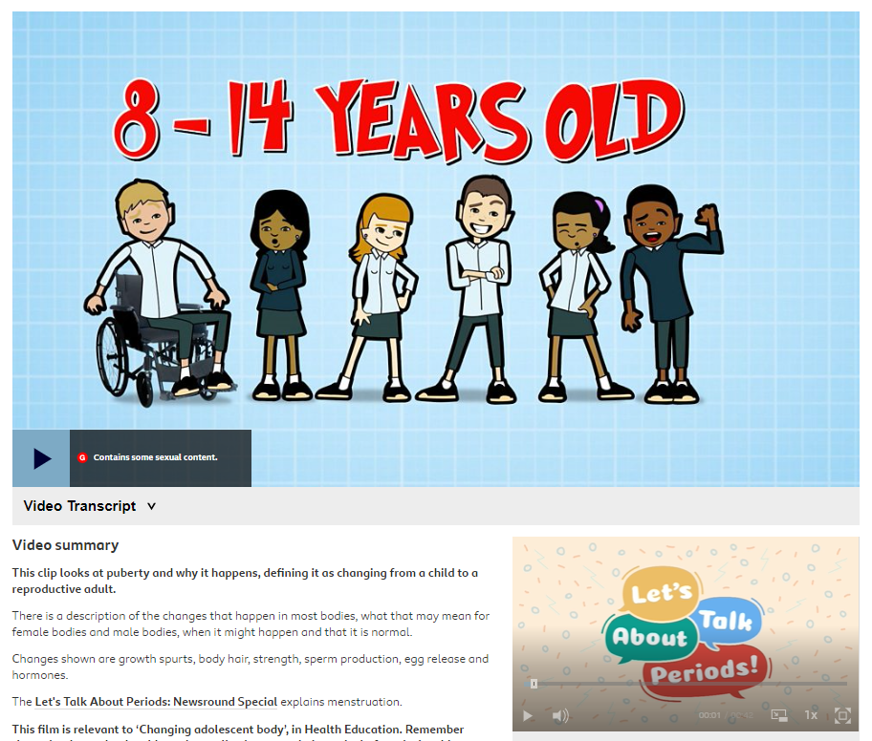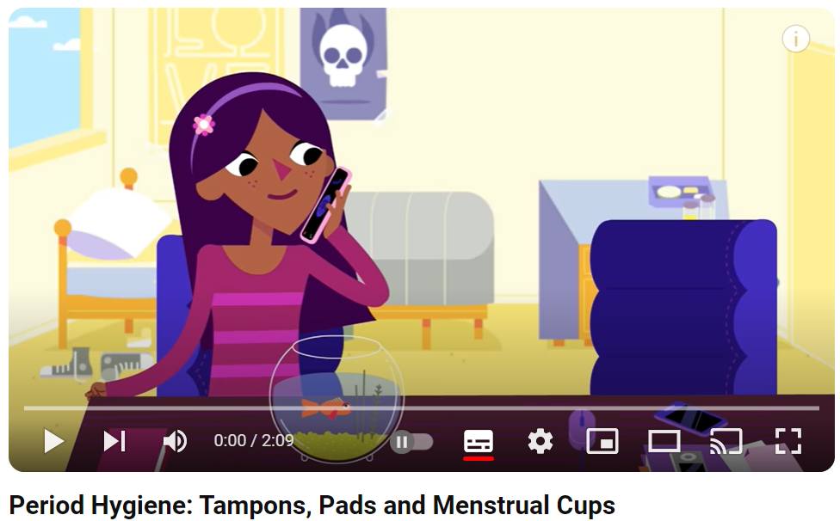
  Teach in separate sex classes
Puberty for boys  SB | Teach but DO NOT TEACH REPRODUCTION  USE LESSONS DEVELOPED BY PSHE COORDINATORS NOT JIGSAW MATERIALS. | Do not teach:  Erection  Ejaculation  Wet dream  Do not teach:  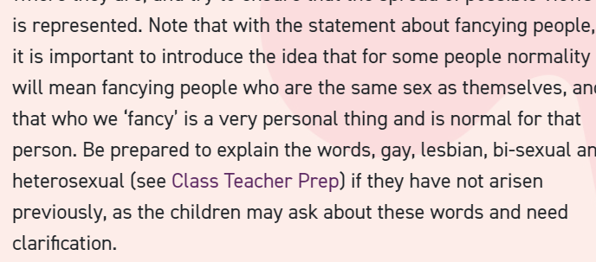
  Teach in separate sex classes
Conception | REMOVE LESSON – not taught in Year 5

Looking ahead 1  SF | Growing responsibilities and consent as children look to becoming teenagers.  Do not use image below.   | Do not discuss in Year 5. 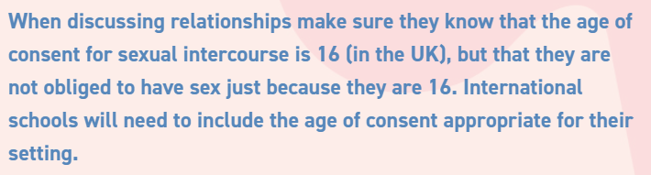
Looking ahead 2 | Same end lesson for this puzzle – preparation for pupils’ next stage of life.  Puberty is mentioned in the lesson plan but not on the slides.

From the PSHE progression grid document – CHECK COMPLETE
In this Puzzle, children explore self-image and self-esteem while learning about physical and emotional changes during puberty.
Across the six Pieces, children reflect on identity, adolescent friendships, and the pressures linked to appearance and growing independence. They practise challenging negative self-talk and identifying trusted adults for support, alongside discussing attraction, consent, and respectful relationships.
This Puzzle includes a non- statutory sex education lesson where develop understanding of reproduction, pregnancy, and birth. (Parental option to withdraw).
By the end of the Puzzle, children consider the transition to secondary school, using Circles of Change to reflect on worries, hopes, and how to prepare confidently for the year ahead.
Age 10-11–2026 materials | Lesson plan/preview amendments | Other comments
My self-image | Life lesson – No change to lesson content.
Year 6 –Puberty  USE ARBORETUM LESSONS.  SF | Lesson developed around these videos.  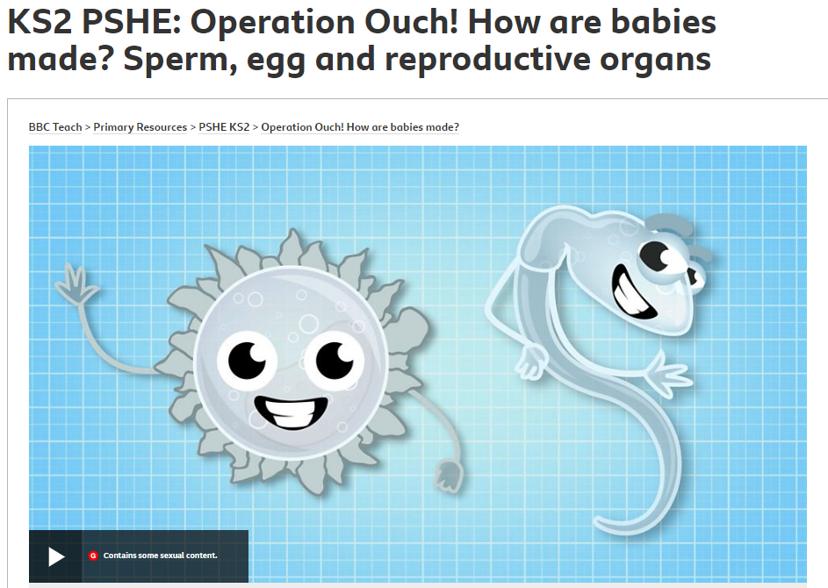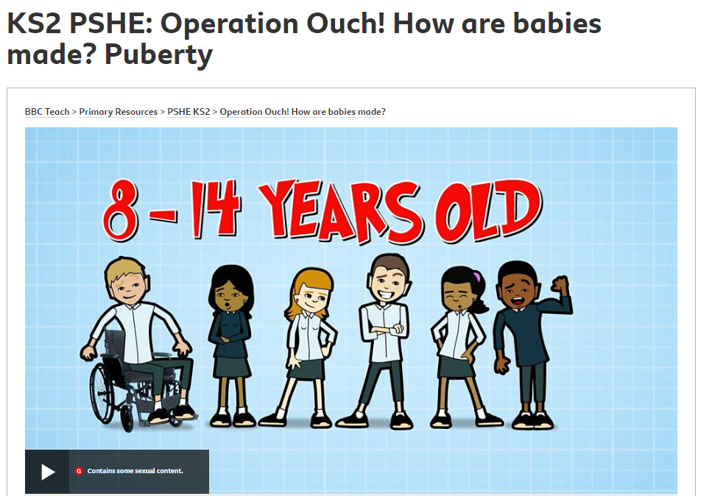 | Do not teach masturbation.
  Teach in separate sex classes
Year 6 - Babies – conception to birth  USE ARBORETUM LESSONS.  SF | Lesson developed around these videos.  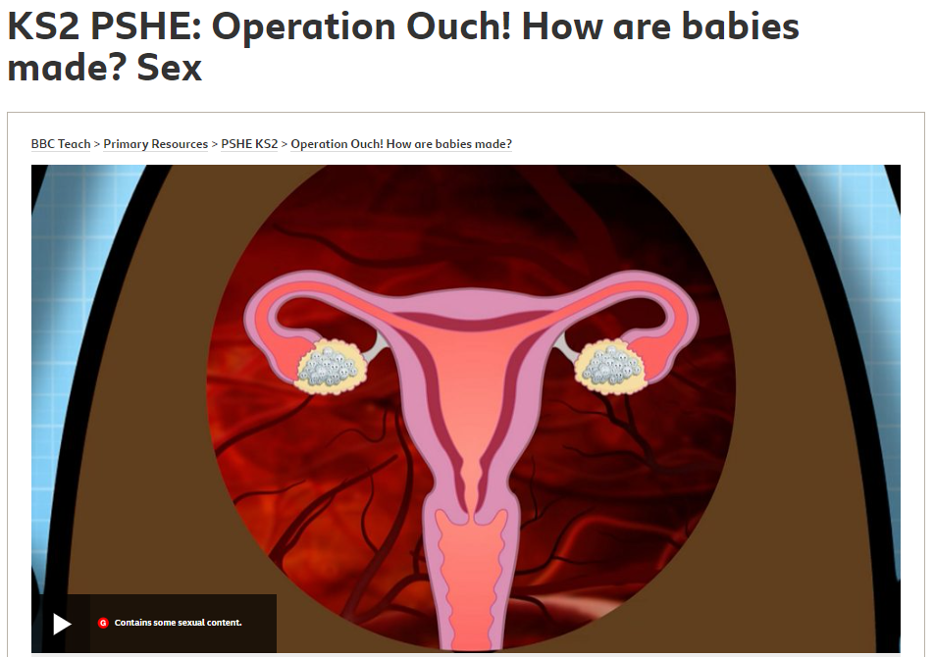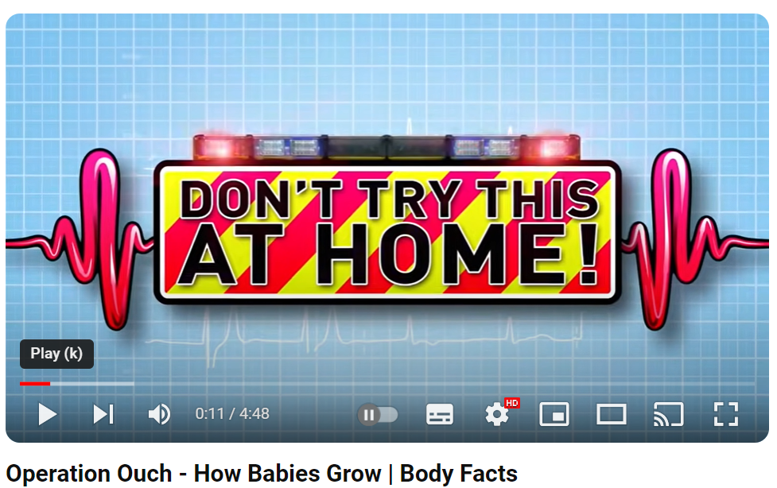 | At Year 6, sexual intercourse is explained in slightly more detail than in the previous year. Children are encouraged to ask questions and seek clarification about anything they don’t understand. Further details about pregnancy are introduced including some facts about the development of the foetus. Children learn that having a baby is a personal choice. Details of contraceptive options and methods are not taught as this is not age appropriate. Reasons why people choose to be in a romantic relationship and choose to have a baby are also explored. NB – parents have the right to withdraw their child from this element of the curriculum as per DfE policy and guidance.
  Teach in separate sex classes
Boyfriends and girlfriends  SB | Case study – sexting.  Lesson should be taught as children are moving to secondary school. | Important lesson to share as it discusses pressure and consent.  Strong focus from OFSTED that females are treated respectfully in school.  Need to recognise that children will have access to their own mobile phones and will be left in homes unsupervised.  ‘Sexting’ may not be discussed at home.  Inform in parent meeting.
Adolescent friendships – Alternative  SB | Alternative lesson to boyfriends and girlfriends but feel we should teach both.  ‘Is fitting in more important than being true to yourself?’  Recognising that children will be entering a phase in their life when they will be meeting many new people and developing the confidence to find ‘their’ people.
Real self and ideal self | Life lesson – self-esteem/challenging negative body talk.  No change to lesson content.
The year ahead | Secondary transfer preparation. No change to lesson content.

